Table of Contents

**Introduction** 2

Guidelines for in-module questions 3

You’ll be hearing from 3

Project and its Significance 3

Introduction to GAN 7

Architecture and Training of GANs 11

Loss Functions of GAN 16

Introduction to DCGAN Demonstration 21

Read More 23

DCGAN Demonstration: Data Preprocessing 23

DCGAN Demonstration: Model Building 24

DCGAN Demonstration: Loss and Checkpoint 25

DCGAN Demonstration: Model Training 26

DCGAN Demonstration: Conclusion 27

**Introduction**

Welcome to the Capstone on ‘**Style Transfer using Generative Adversarial Network (GAN)**’.

Let's start exploring the capstone by understanding the problem statement at hand. There are various types of MRI that have the ability to capture different types of abnormalities. However, one type of MRI may not be sufficient in capturing a particular type of abnormality. In this case, having another type of MRI may enhance the accuracy of a diagnosis, thus leading to better treatment of the patient.

However, gaining access to different imaging techniques is difficult and expensive. Also, doctors often prescribe one type of MRI at once, but what if you could create another type of MRI from the one that we already have? Moreover, without investing the same amount of time and money?

Generative adversarial networks (GANs) provide the luxury of creating another type of MRI from the existing one. In this capstone, you will use a particular variant of GANs, called CycleGAN, to translate the style of one MRI image into another. This will help in gaining a better understanding and analysis of the scanned image. By using GANs, you will create T2 weighted images from T1 weighted MRI images and vice-versa.

In the next video, our subject matter expert, Snehansu will introduce you to the key concepts that you will be covering in this capstone.

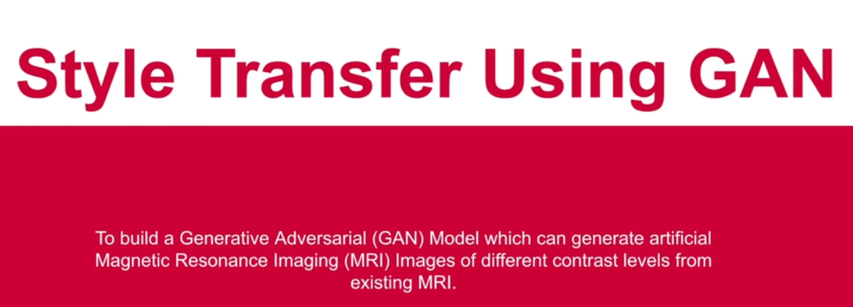

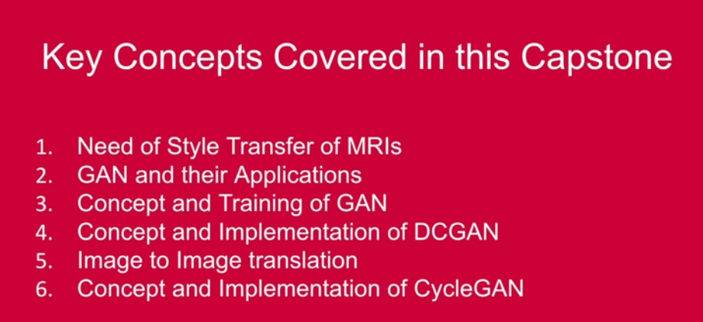

In this session, you will learn the following:

* Introduction to the capstone
* Overview of GAN and its applications
* Training of GAN
* Code demonstration of DCGAN

## Guidelines for in-module questions

The in-video and in-content questions for this module are not graded. The graded questions are given in a separate segment at the end of the module. These questions will adhere to the following guidelines:

|  |  |  |
| --- | --- | --- |
| Marking system for Graded Questions | | |
|  | First Attempt Marks | Second Attempt Marks |
| Questions  with 2 Attempts | 10 | 5 |
| Questions  with 1 Attempt | 10 | 0 |

## You’ll be hearing from

[Snehansu Sekhar Sahu](https://www.linkedin.com/in/snehansu-sekhar-sahu-iisc/)

**Senior Research Engineer in ML and AI at American Express.**

Snehansu has risen through ranks after his Bachelors in Electronics and Communication Engineering from VNIT Nagpur batch 2012. He worked with Qualcomm for 3 years before breaking into the Data Science industry. A Masters in Computational Data Sciences from IISC Bangalore batch 2017, Snehansu has acquired a diverse skill set in the area of Data Science. With a vast industrial experience of over 7+ years, he has achieved a senior position in American Express’s research and development team. He works as a Senior Research Engineer, where he gets a lot of real-time experience of innovative technologies in the domain of Data Science.

# Project and its Significance

In the previous segment, Snehanshu introduced you to the key concepts that would be dealt with in this capstone. Let’s take a look at the next video to understand the problem statement in detail, before moving on to the technical concepts.

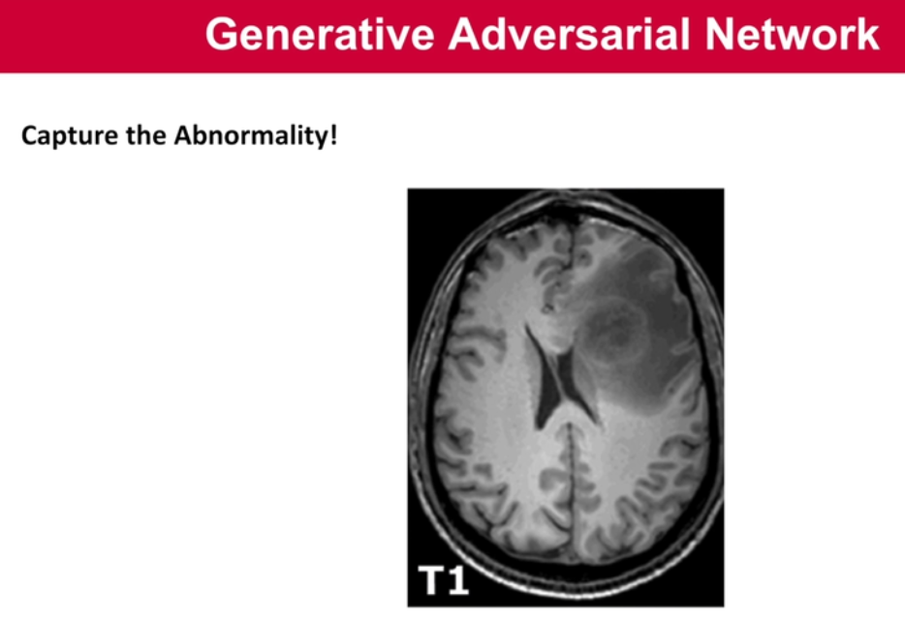

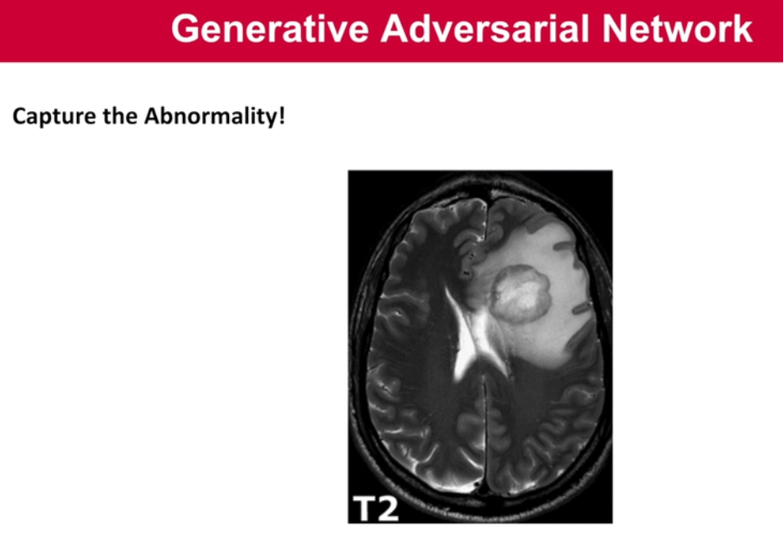

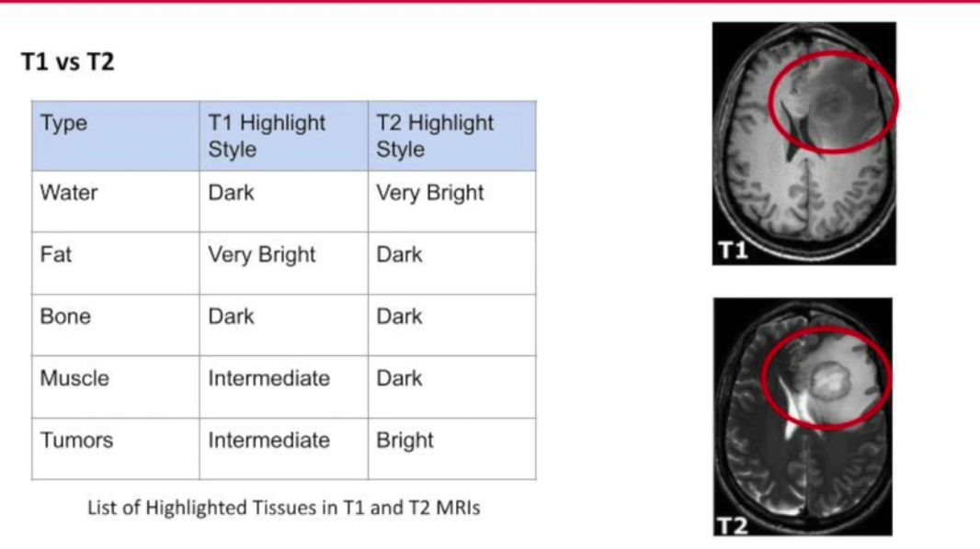

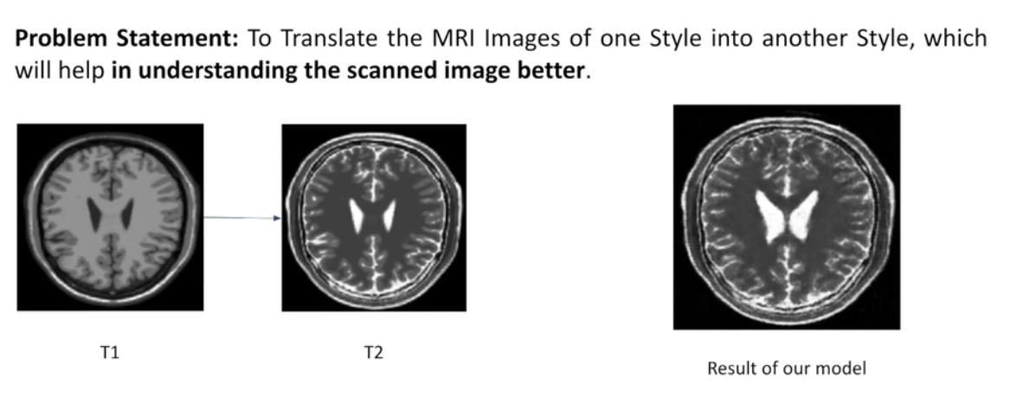

So far, you understood how T1 and T2 MRIs differ from each other, and most importantly the reason why they are not a complete contrast of an image. To put things in perspective, we have the following table.

|  |  |  |
| --- | --- | --- |
| **Type** | **T1 Highlight Style** | **T2 Highlight Style** |
| Water | Dark | Very Bright |
| Fat | Very Bright | Dark |
| Bone | Dark | Dark |
| Muscle | Intermediate | Dark |
| Tumours | Intermediate | Bright |

Let’s summarise the T1 and T2 type MRIs in concrete terms. There are some component types such as Water, Fat, Muscle and Tumors which establish contrast relationship between MRIs. Moreover some of the elements have different contrast level whereas Bone component in MRIs gets highlighted in the same way in both the MRIs. Hence we can see that it’s a partial contrast but not complete contrast. As this is not a complete list of components that are highlighted in the MRIs, to learn more about T1 and T2 images, you may visit [here](https://www.radiologymasterclass.co.uk/tutorials/mri/t1_and_t2_images).

**Problem Statement:** Our goal in this capstone is to convert T1 type MRI images into T2 type MRI images. This way we can create a revolutionary impact in the healthcare sector.

For the dataset refer to the zipped file given below.

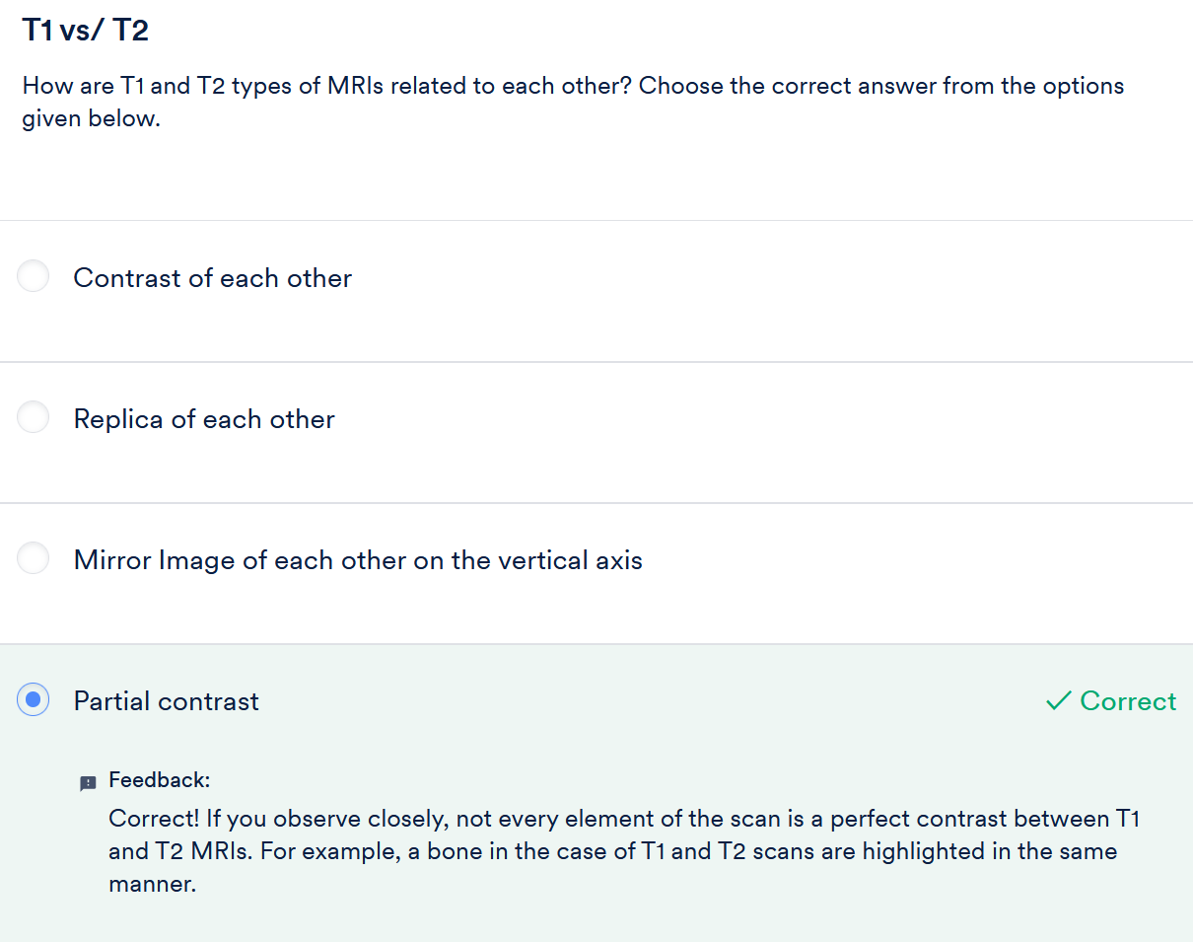

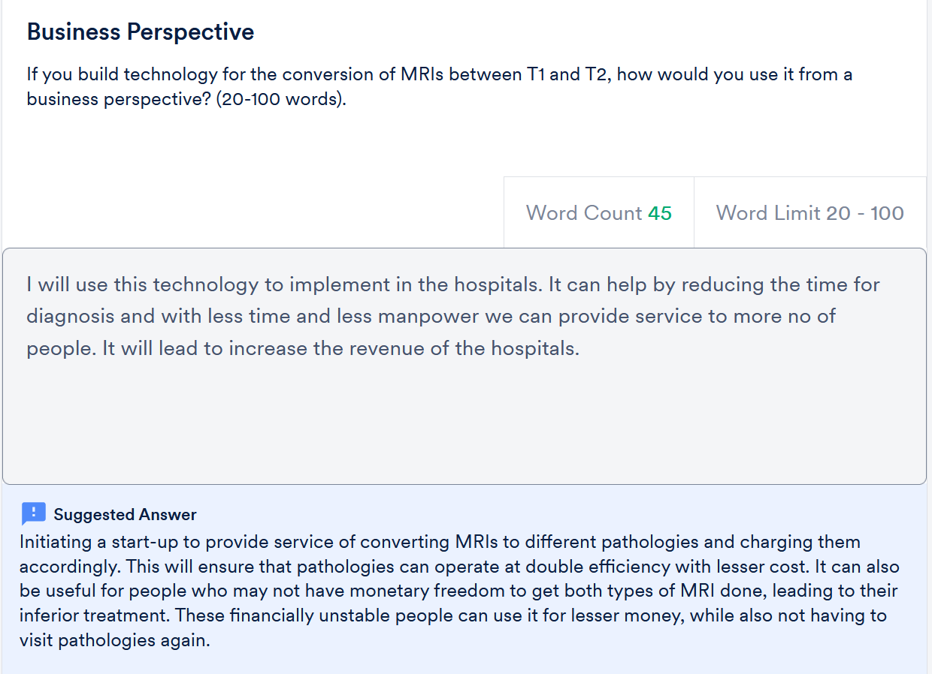

# Introduction to GAN

Now that you understood the problem statement, let’s take a look at the kind of models that you can use to solve the problem. The first approach that comes to our mind is neural style transfer, which solves similar use cases.

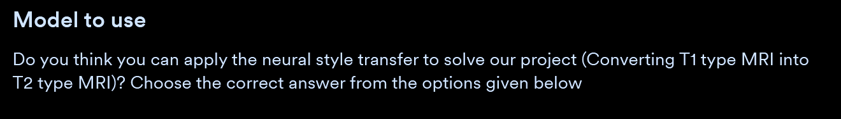

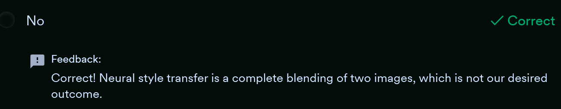

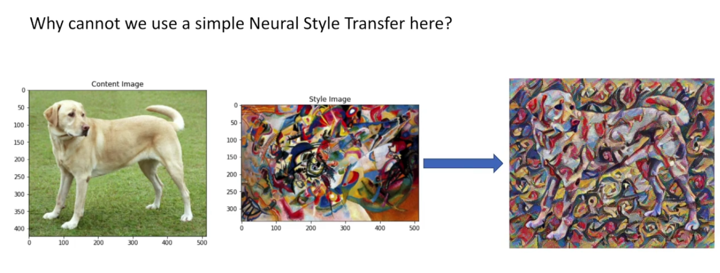

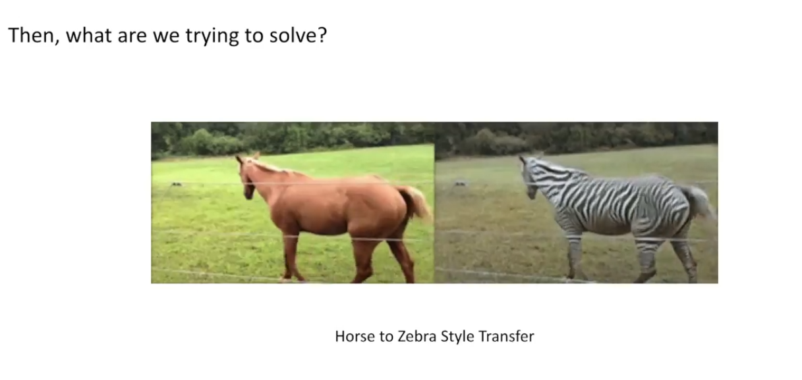

So now it is clear that neural style transfer is more of an image blending or complete style transfer, whereas horse to zebra style transfer is an example of selective style transfer, as you can see that in both the images, the background is not changing in style, whereas the style of zebra is being rendered on the horse.

We use **CycleGAN** for solving such problems, which we will see in later segments.

But, you might wonder why our problem of converting T1 type MRIs into T2 type does not correspond to the neural style transfer? Let’s take a look at the approach we need to follow for MRI conversion between T1 and T2 in the next video.

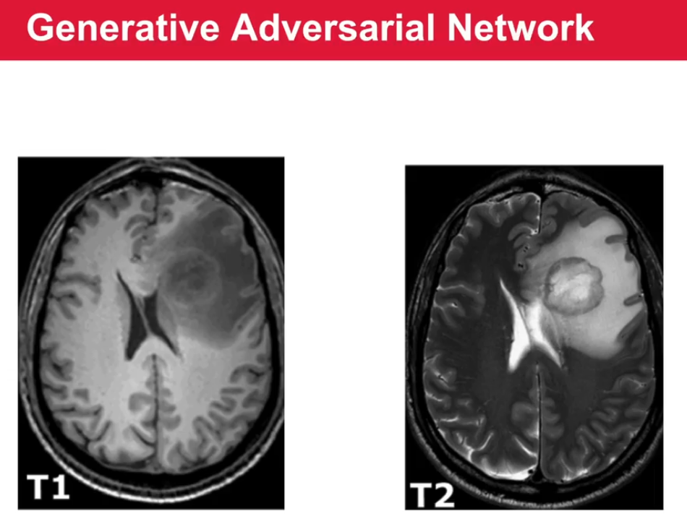

We saw that MRI style transfer is not an unconditional blending of images. We need to do selective style transfer, for which you already know that you can use GAN. However, this is not the only thing GANs can do. Let’s look at the next video which highlights a few applications of GANs.

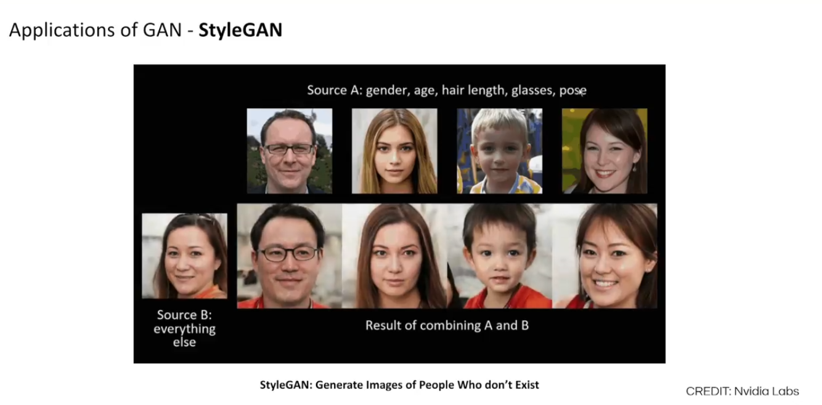

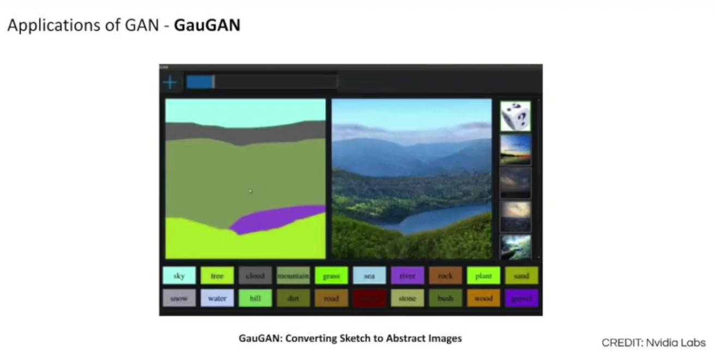

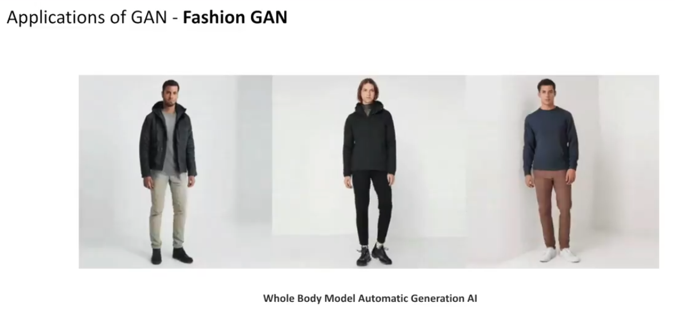

GAN is used for generating various kinds of data, be it images, videos, audio etc. When we use it for specific use cases, we make some variations in the basic GAN architecture to obtain better results. Some of these specific use-case solving GANs are Fashion GAN, Gau GAN, Style GAN, etc.

So far, you understood that you would need to use cycleGAN to resolve the problem statement at hand, which is a complex variant of GAN hence let’s begin by exploring the concept of GANs in the upcoming segments.

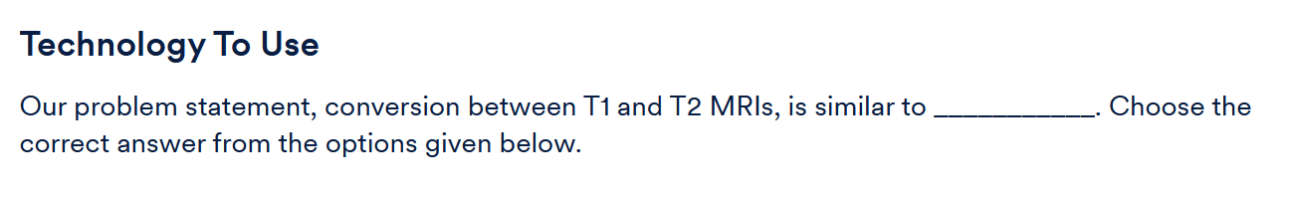

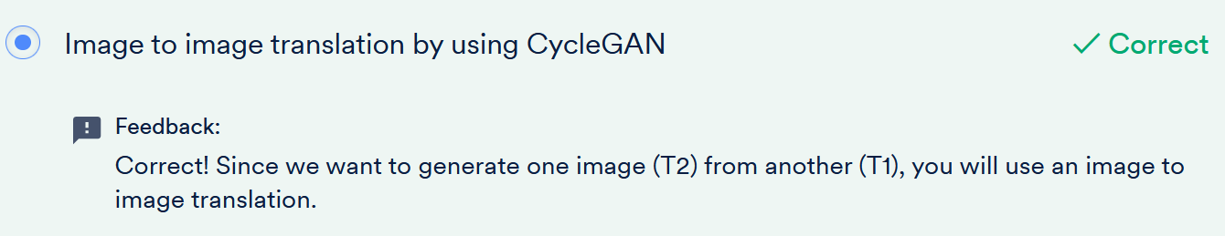

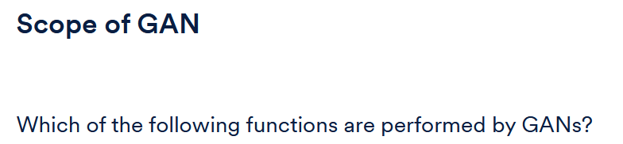

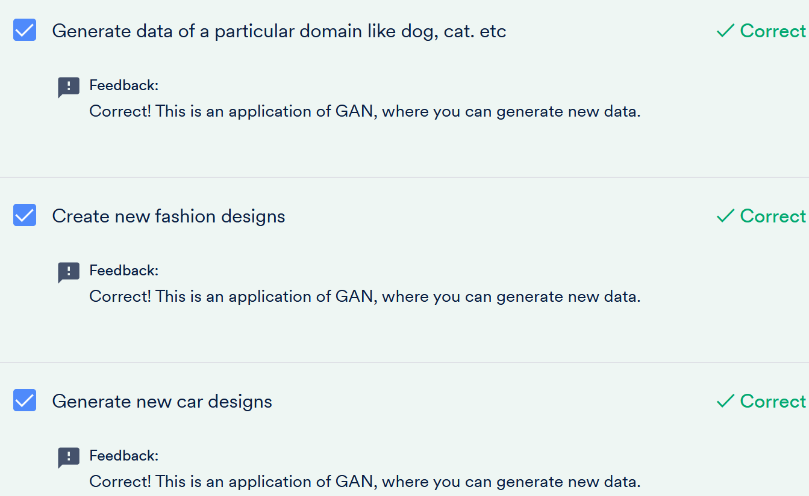

# Architecture and Training of GANs

So now you know what the basic use cases of GANs are and where you can use them. You also saw some real life applications being used currently.

In the next video, you will analyse the constituents of GANs that allows them to be quite effective in generating samples.

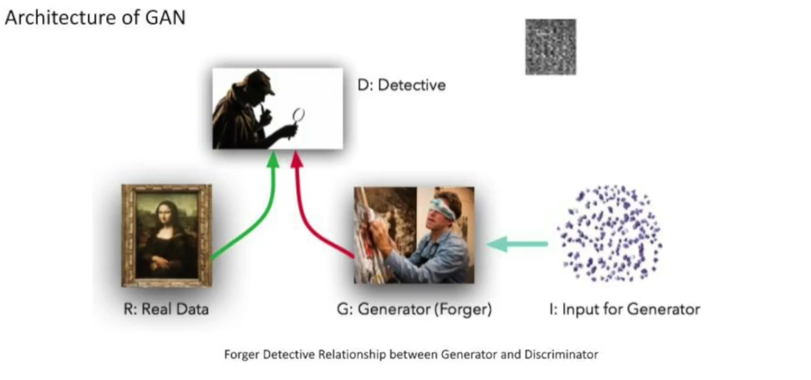

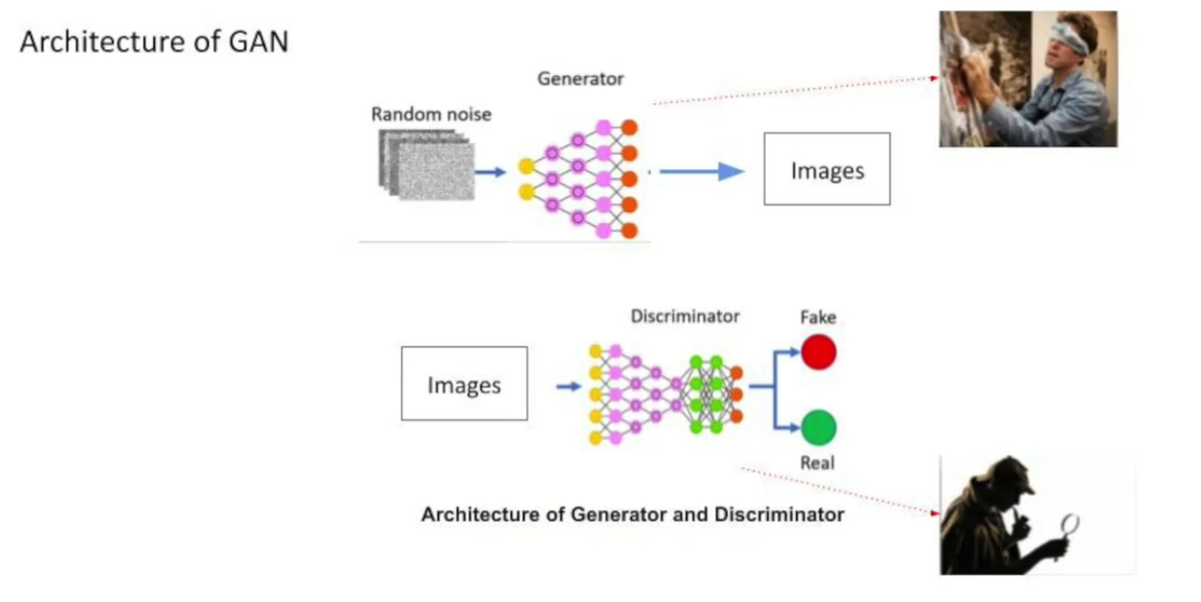

GANs or General Adversarial Networks are one of the coolest innovations in machine learning.  They are the types of generative models through which you can create new data points that can resemble the original data to such an extent that it can even fool the human eye.  They reach this level by combining two neural networks competing with each other.

On one hand, you have a discriminator which is a classifier. Further, this model can classify an image as real or fake after enough training. On the other hand, we input some random noise to the generator and it creates an image out of it. Hence the two models, namely, generator and discriminator, are coupled in an adversarial relationship. They both force each other to become a better version of themselves.

To explain this Snehansu gave a real-life example of forger and detective. Forger wants to create fake images of Picasso to fool the detective, whereas the detective wants to catch the forger by learning about real Picasso images. When we relate this scenario with GAN, forger corresponds to the generator and detective corresponds to the discriminator.

Let's take a look at the next video to understand how this adversarial relationship affects the step-by-step training of both the generator and the discriminator.

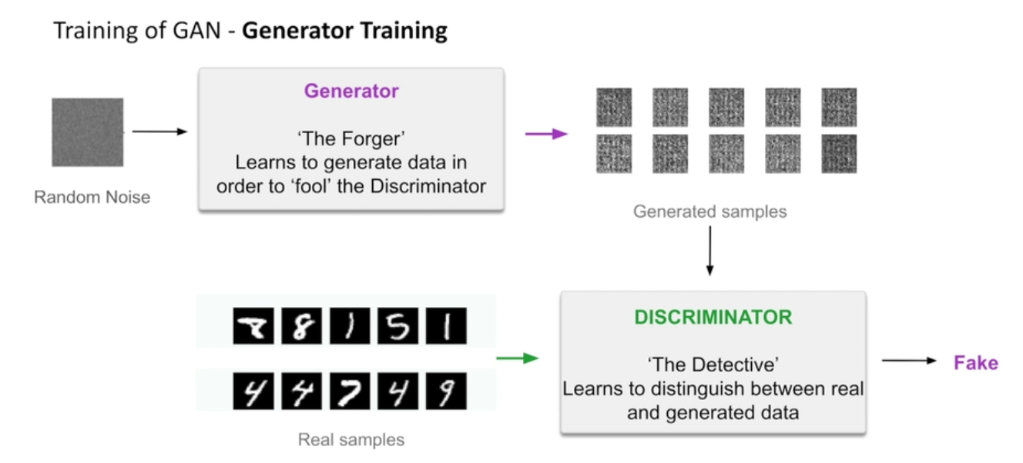

Initially, both the generator and the discriminator are new and unskilled. Hence, the generator from the input noise will produce a random dumb image. At that time, the discriminator (which is also not that skilled) can easily classify a dumb image as fake. Thus, the generator fails in decreasing the error rate of the discriminator. This is a signal for the generator to get better at producing new images. Let’s see what happens next.

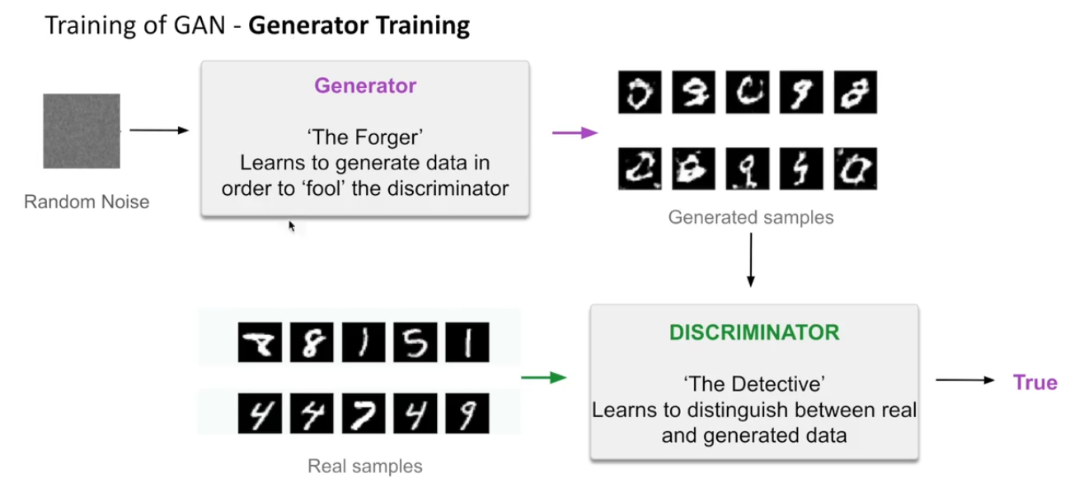

With further training, it produces new images that are indistinguishable from the discriminator and it gets fooled. And now, the discriminator is forced to train to decrease this error rate. This game of discriminator getting fooled and generating getting caught goes on. Let’s see how this game goes on and what happens at the end. 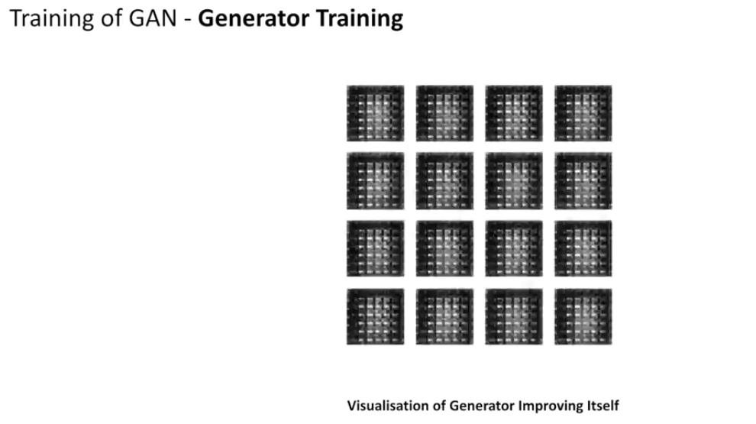

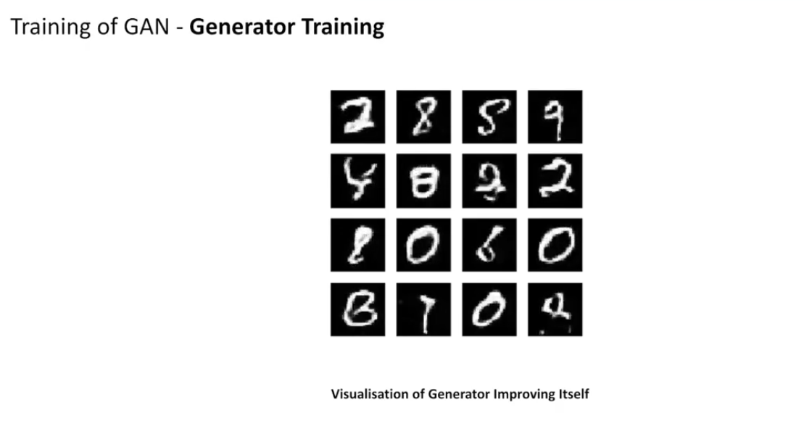

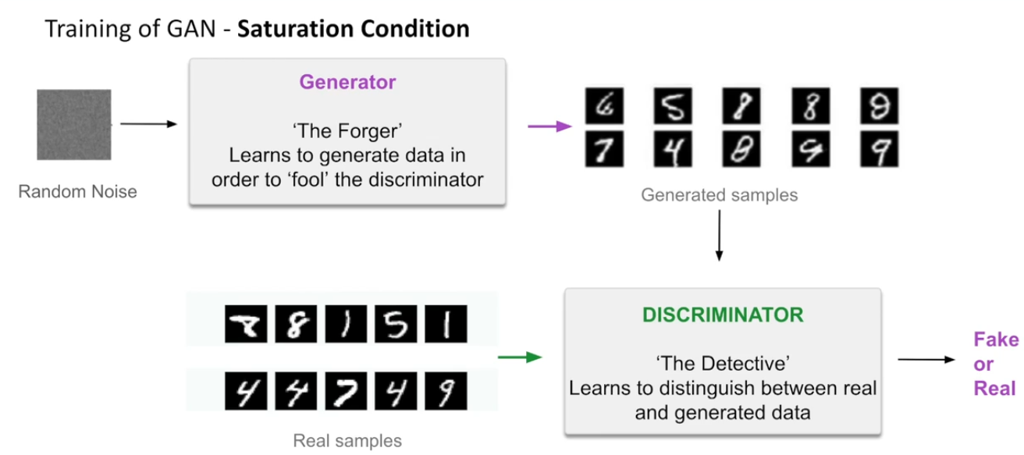

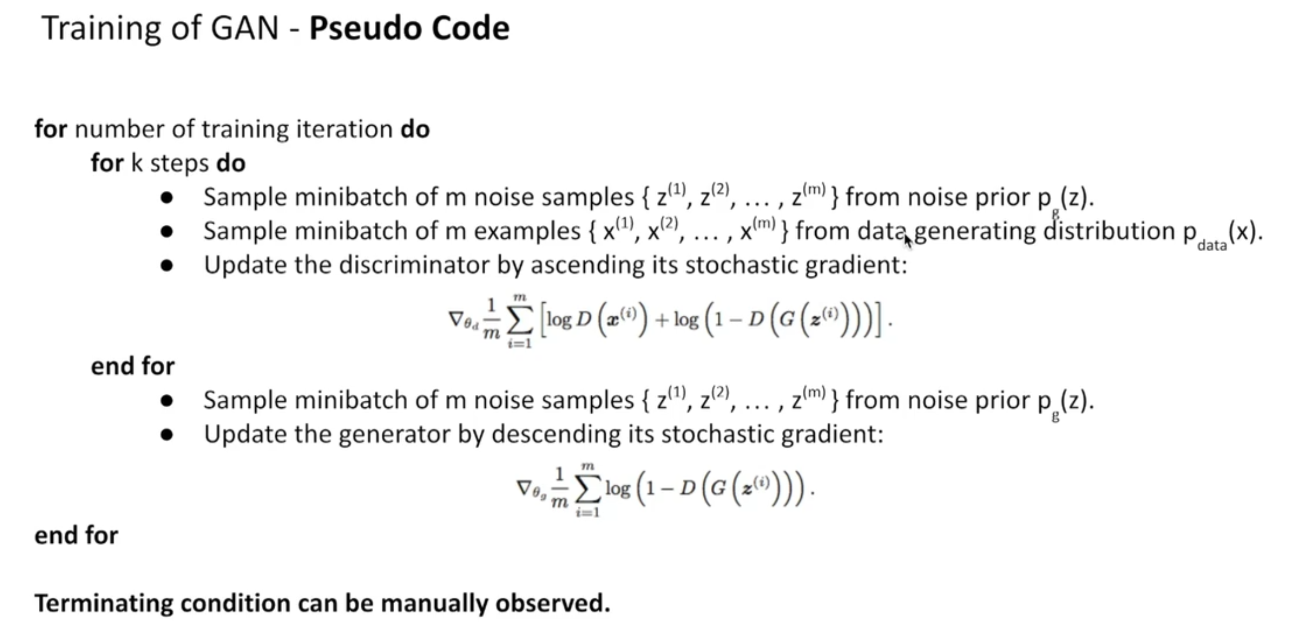

This cycle continues to go on and on up to a certain point where the generator identifies what makes the image real. Therefore, whatever it creates resembles the original training data. Thus, the discriminator always produces 0.5 as output, which means that it is unsure of it being real or not. At this point, if you throw away the discriminator, you will be left with a generator that can generate images which mostly resembles the original one with just noise as its input.

Suppose your teacher keeps reprimanding you for your poor marks in mathematics, even though you score a perfect 10 in the rest of the subjects.  The teacher is the kind of adversary who keeps focussing on your weakness. So after training, if everything goes well you might get a 10 in mathematics too. Also, there is a possibility that you might hate your teacher. However, since neural networks lack emotions, you do not have to be concerned about that here.

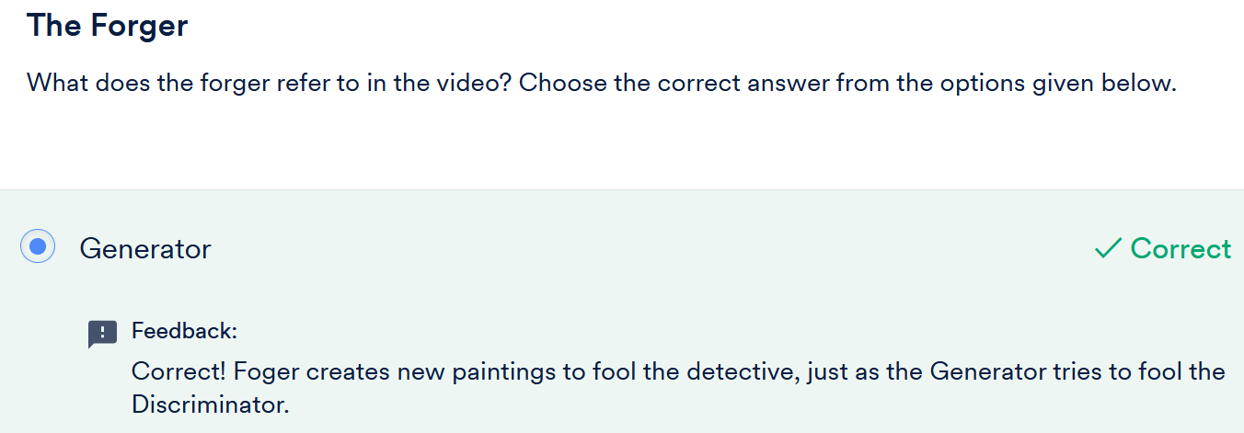

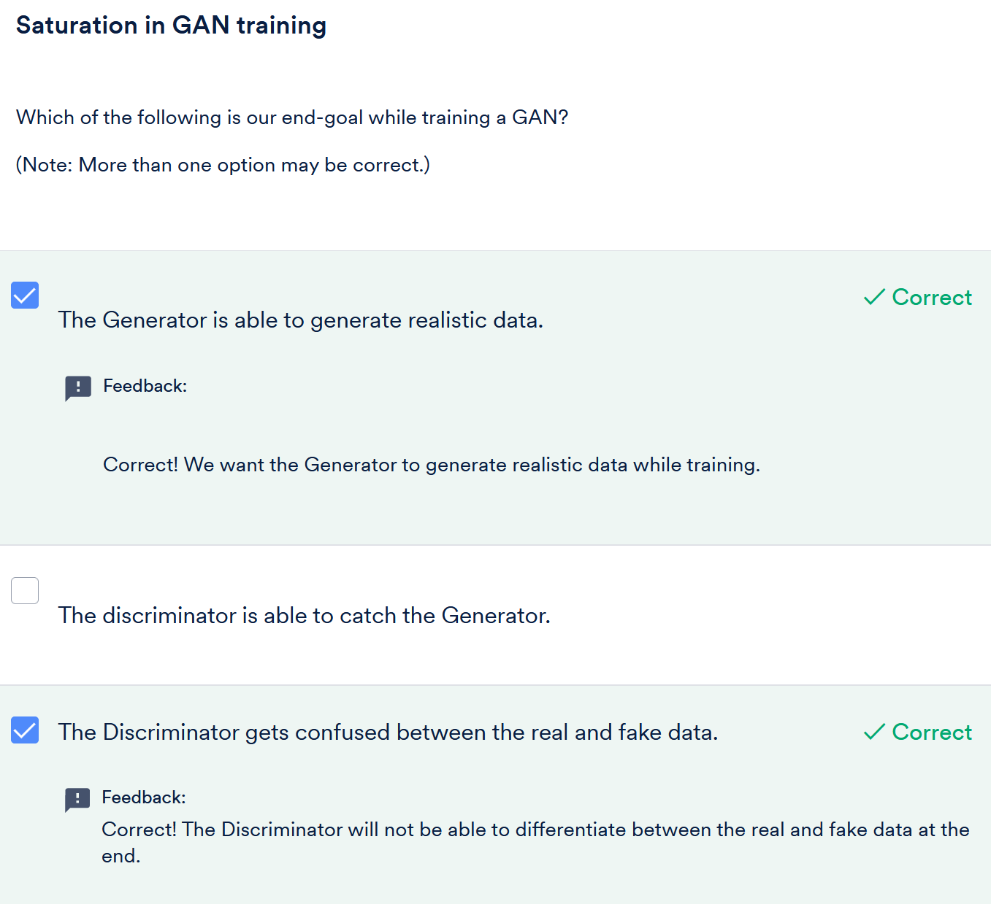

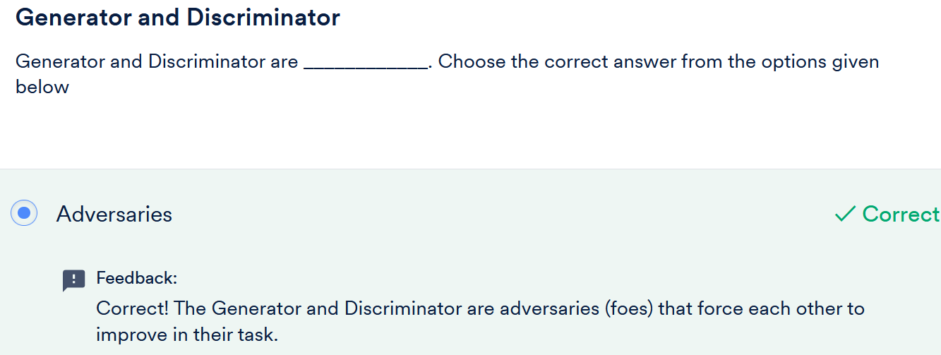

# Loss Functions of GAN

As you already know, training in ML models is possible as a result of loss functions. Let’s watch the next video to understand the loss functions that are used in GAN.

We’ll first start with the  discriminator, which is a binary classifier, as we saw in previous segments.

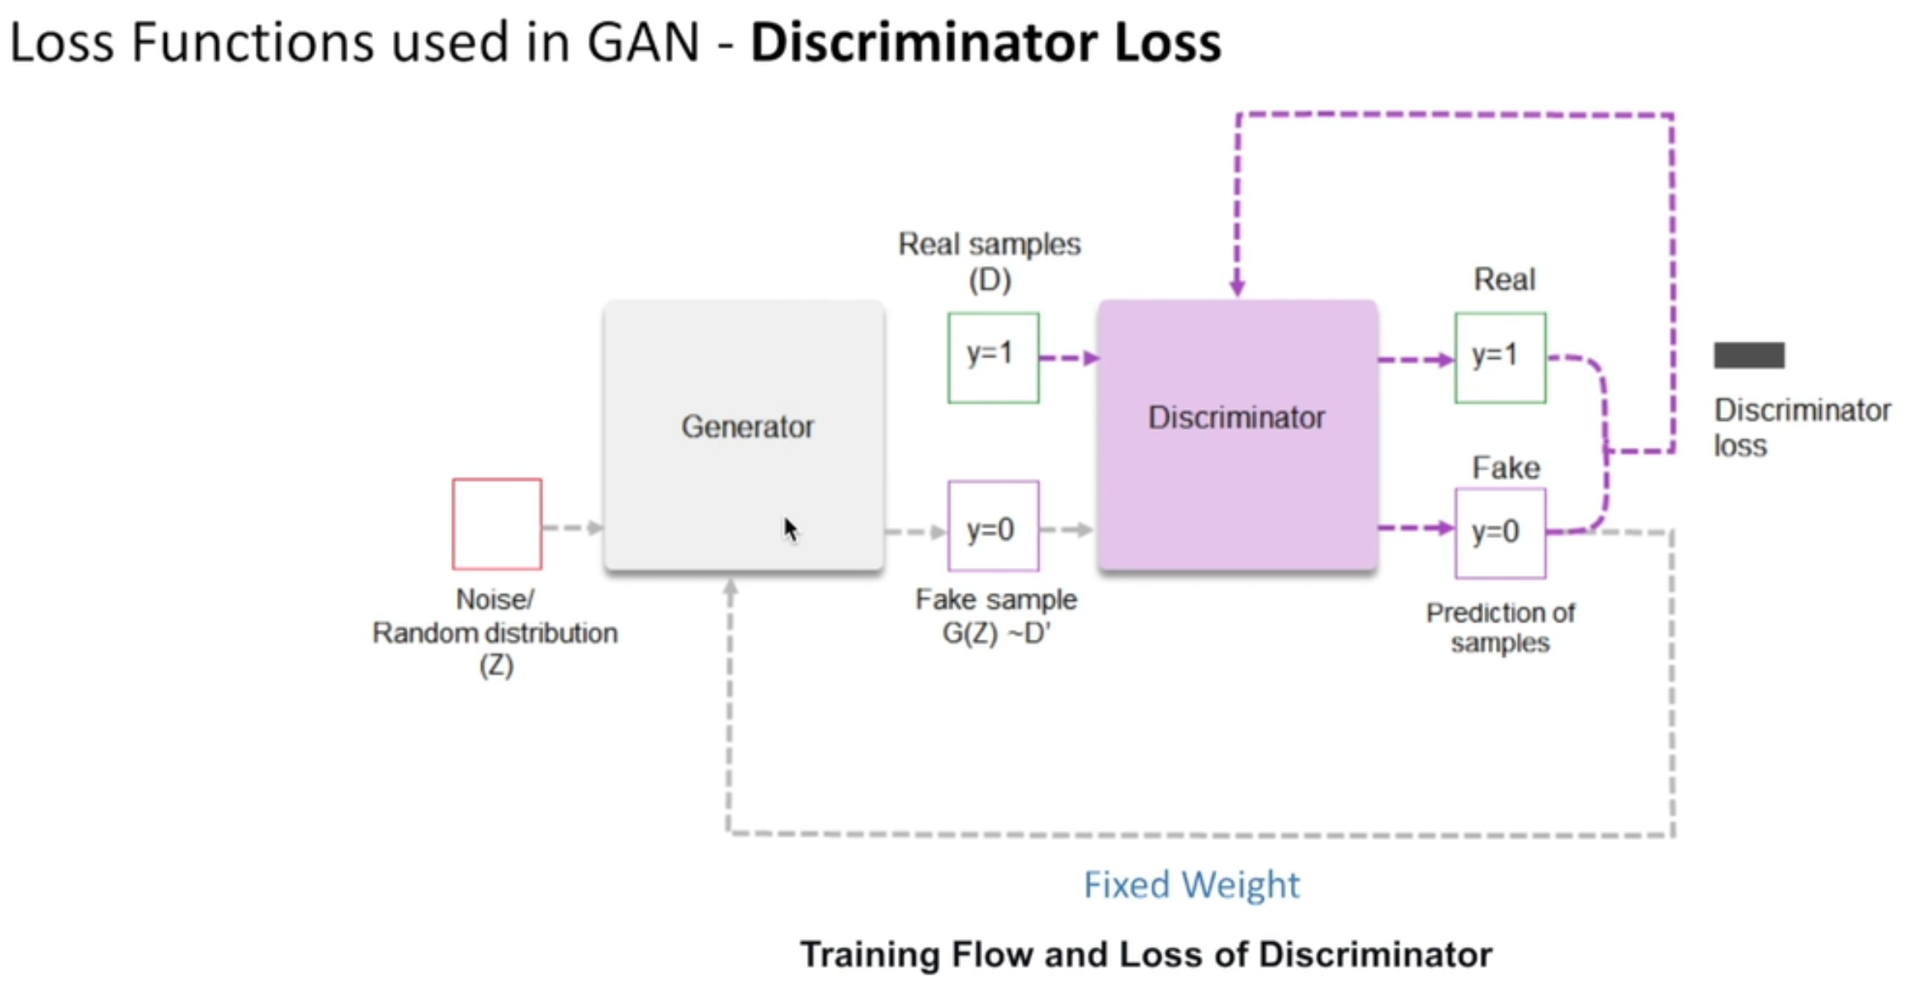

In the video, you learnt about the concept of loss of the discriminator, and it can be summarised as follows:

There are two loss functions that are connected to the discriminator. During discriminator training, you should not consider the generator parameters such as weights, biases and generator loss. The discriminator classifies both the real data and fake data from the generator. The discriminator loss penalises the discriminator for misclassifying a real instance as fake or a fake instance as real. The weights of the discriminator are updated through backpropagation from the discriminator loss, through the discriminator network.

Now, let’s take a look at the next video to explore the generator loss, which uses a **deconvolutional neural network** to generate images from noise.

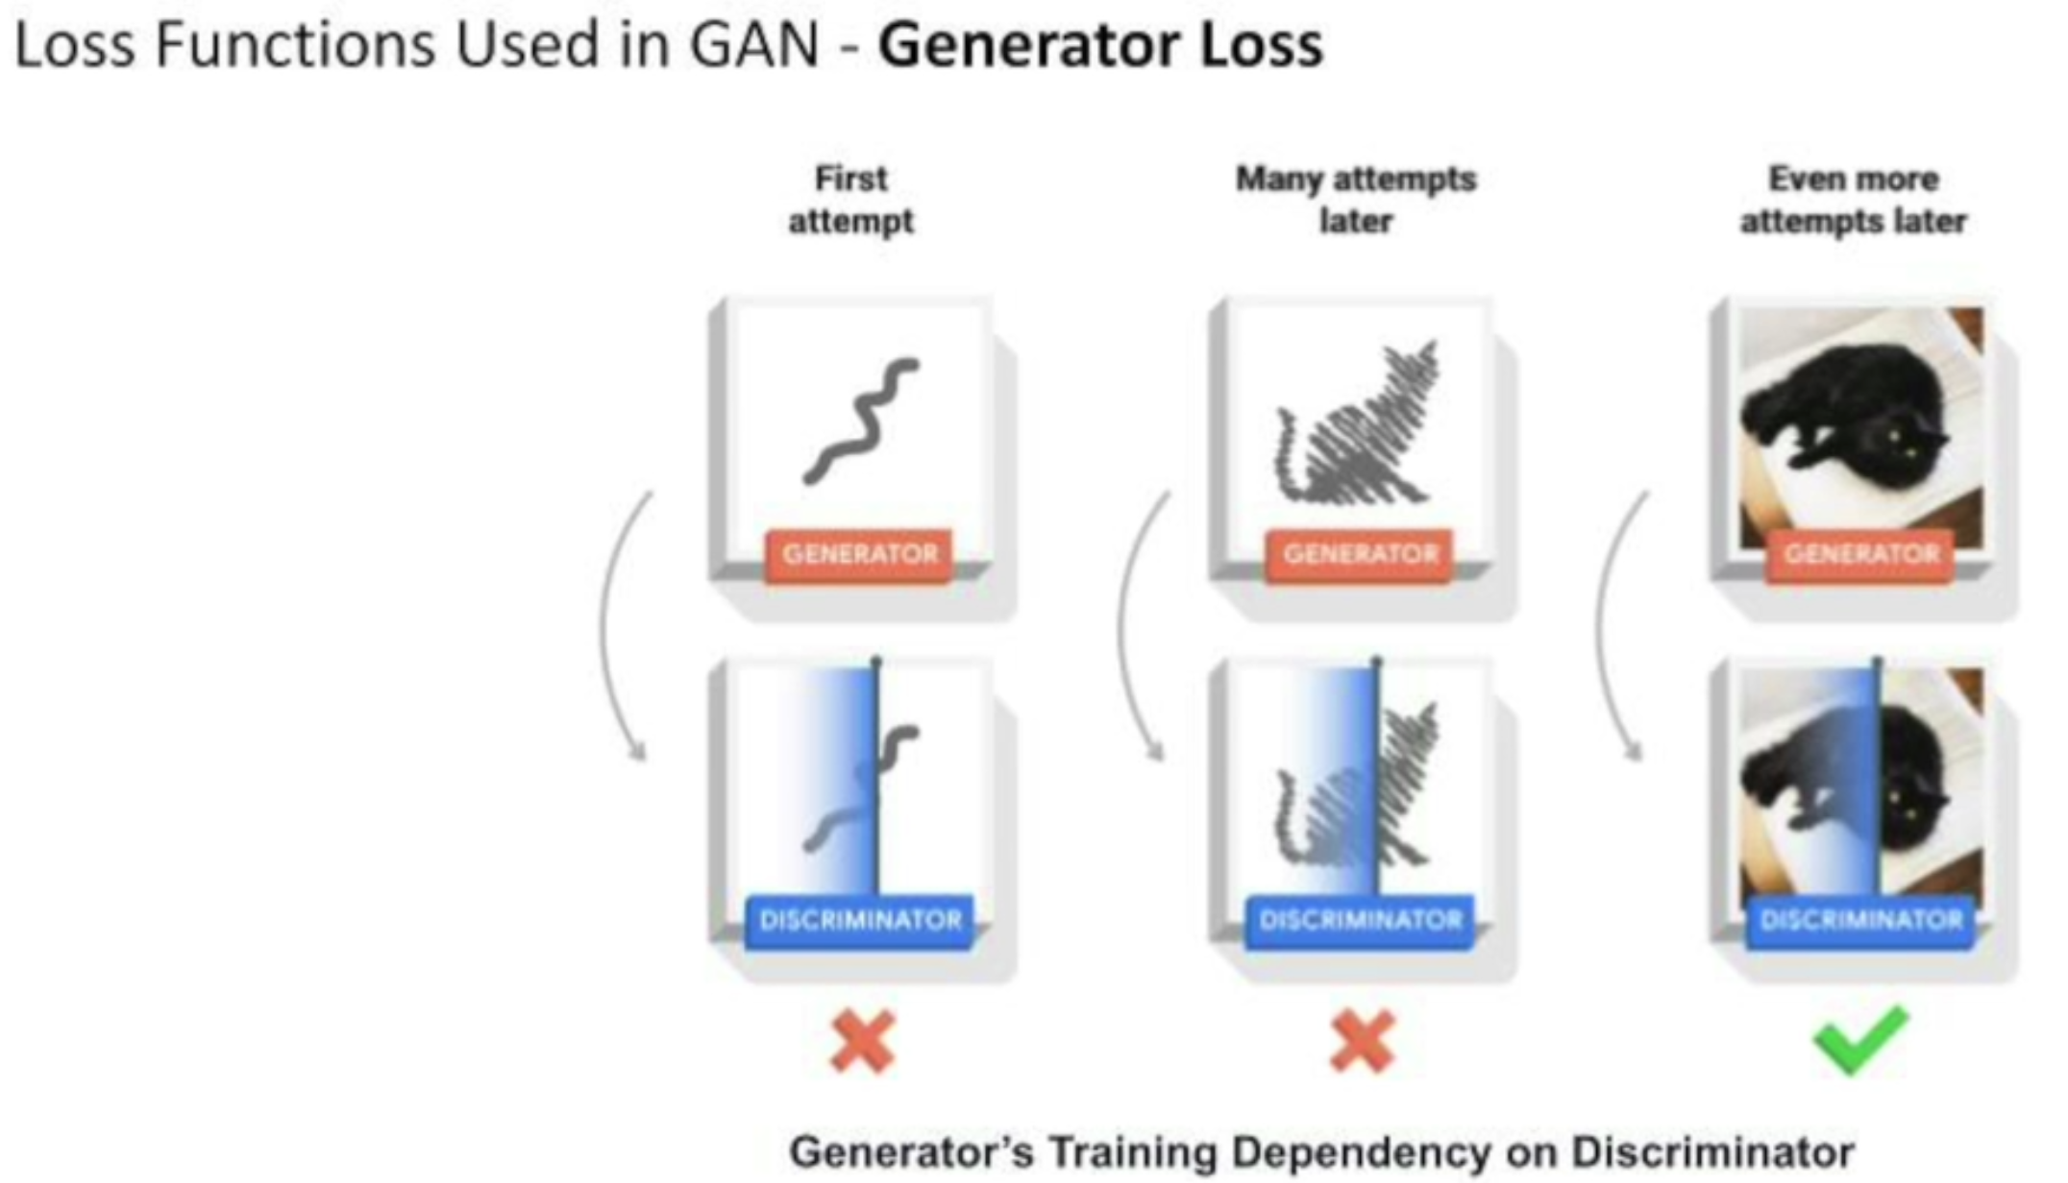

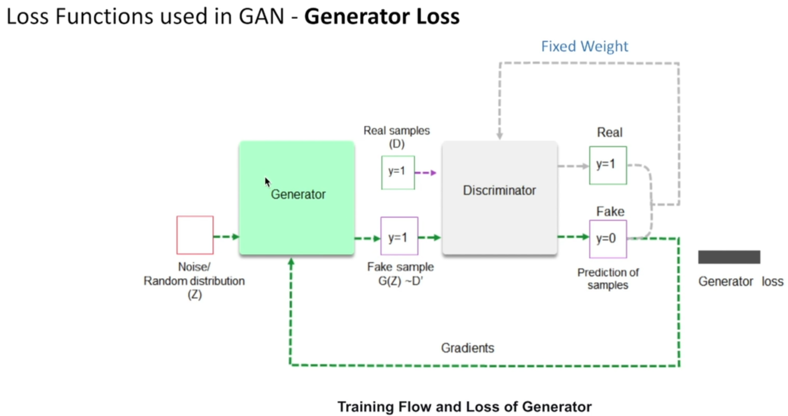

In the video, you analysed that while training the generator, the discriminator is kept fixed, that is, the weights and biases of the discriminator are not trained. The reason behind this is that the discriminator should not become too strong to classify all the outputs of the generator as fake. In its most basic form, a GAN takes random noise as its input. The generator then transforms this noise into a meaningful output. By introducing noise, you can get the GAN to produce a wide variety of data by sampling from different places in the target distribution. Then, the discriminator classifies it as ‘Real’ or ‘Fake’. Next, the loss is calculated from the discriminator classification. Further, the gradients that are obtained from the backpropagation through both the discriminator and the generator are used to change only the generator weights.

Now, let’s take a look at the next video to understand the calculation of losses for both the models starting with the discriminator.

Let’s first look at the discriminator loss for the real data.

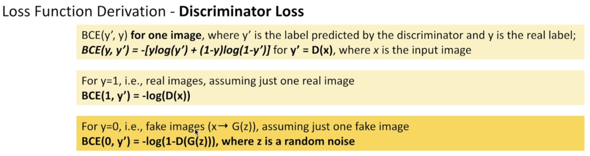

The discriminator will have a similar binary cross-entropy loss for the fake data as well, as we will calculate in the next video. We’ll also combine both the losses.

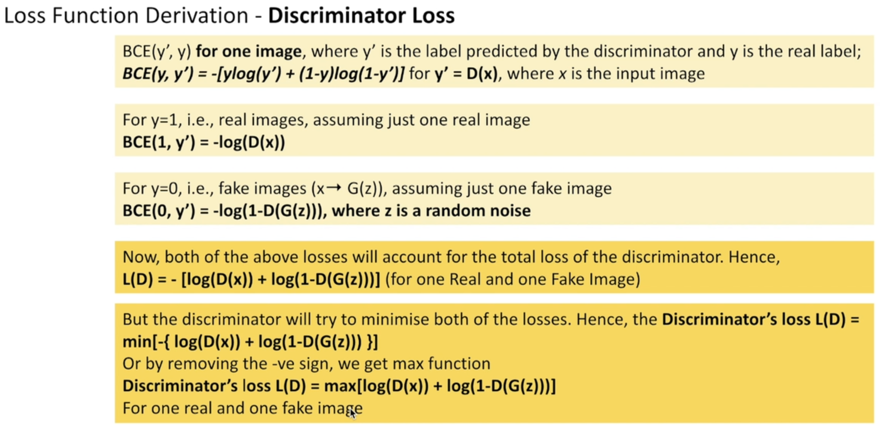

In the video, you saw that you can easily calculate the loss based on our conceptual understanding of the discriminator.

Let's summarise the key points in the following manner:

While training the discriminator, the label of data coming from the real set is y=1 ( real data) and ? = D(x)

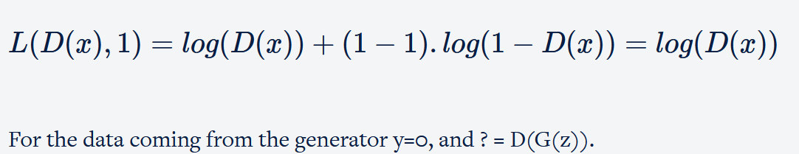

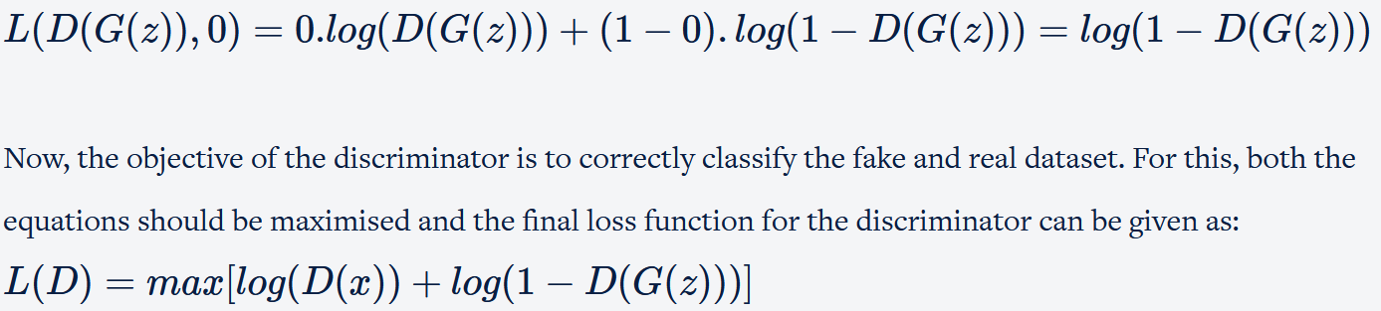

In the next video, we’ll see that surprisingly the generator derives its loss from the discriminator.

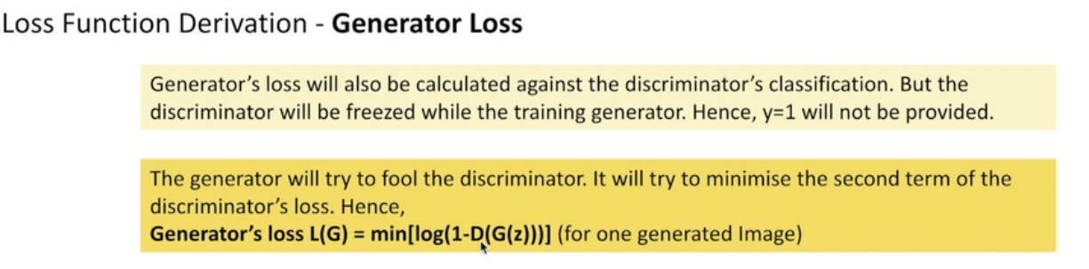

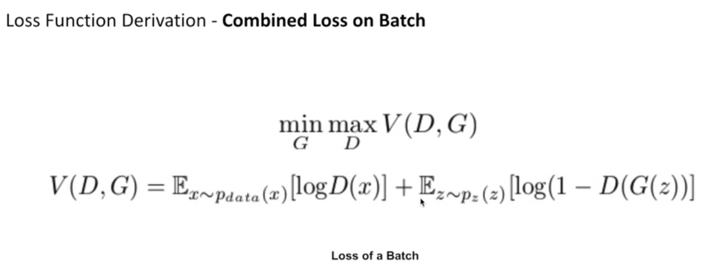

Did you notice that the generator uses the discriminator loss in an indirect manner to train itself?

The objective of the generator is to fool the discriminator so that it tries to minimise the above loss. But remember that during the generator training, the discriminator is frozen and y=1 ( real data) is not provided (thus, log(D(x)) term vanishes from the above loss), and therefore, the final loss function for the generator can be given as :

**L(G)=min[log(1−D(G(z)))]**

Upon combining both the equations, min is applicable for the generator loss function and max is applicable for the discriminator loss function.

**L=minGmaxD[log(D(x))+log(1−D(G(z)))]**

Note that this loss function is applicable for a single data point and you need to take the average while taking a batch of images.

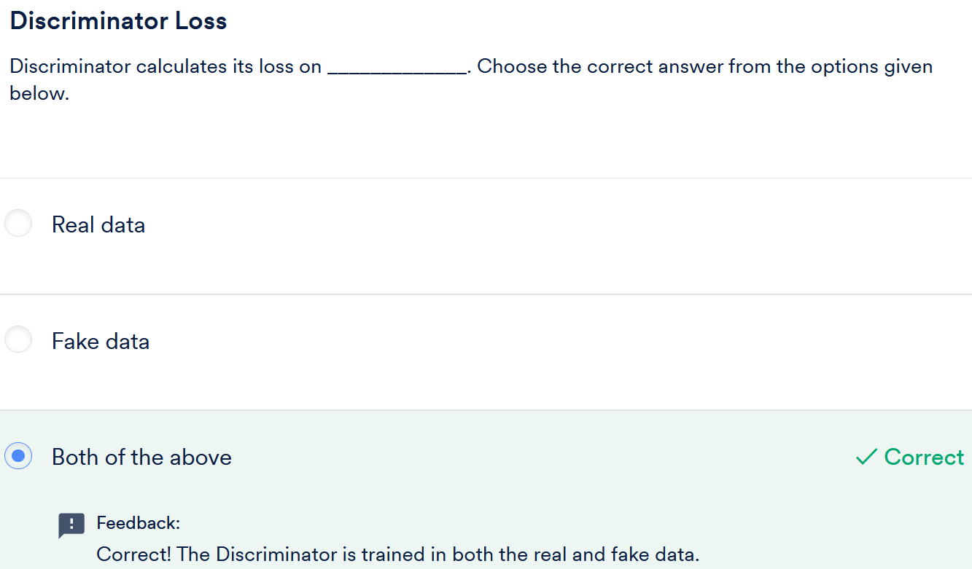

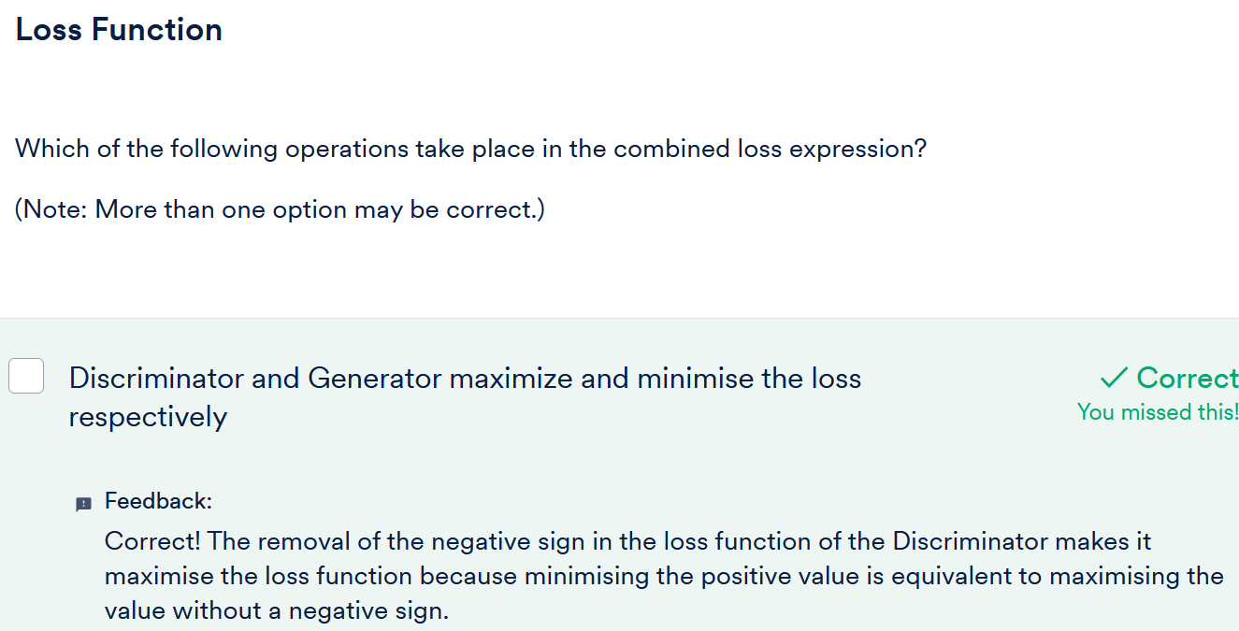

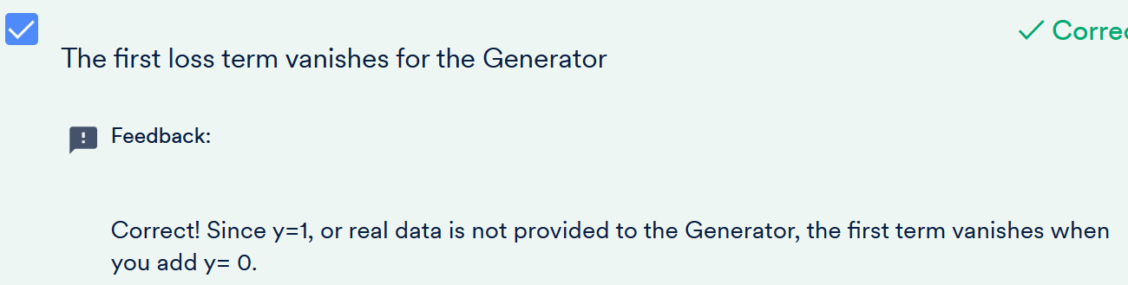

# Introduction to DCGAN Demonstration

GAN, when used to generate images with the help of a deep convolutional network, is termed as DCGAN (Deep Convolutional Generative Adversarial Network). Hence, all the properties of basic GAN are applied to DCGAN in the same manner.

A DCGAN works similarly to GAN, but it specifically focuses on using convolutional neural networks in the place of those fully-connected networks. As you learnt earlier, conv nets, in general, find areas of correlation within an image, that is, they look for spatial correlations.

This means that a DCGAN would likely be more fitting for the image or video data. Whereas, the general idea of a GAN can be applied to wider domains, as the model specifics are left to be addressed by the individual model architectures.

In the next video, Snehansu will introduce you to the notebook on DCGAN implementation.

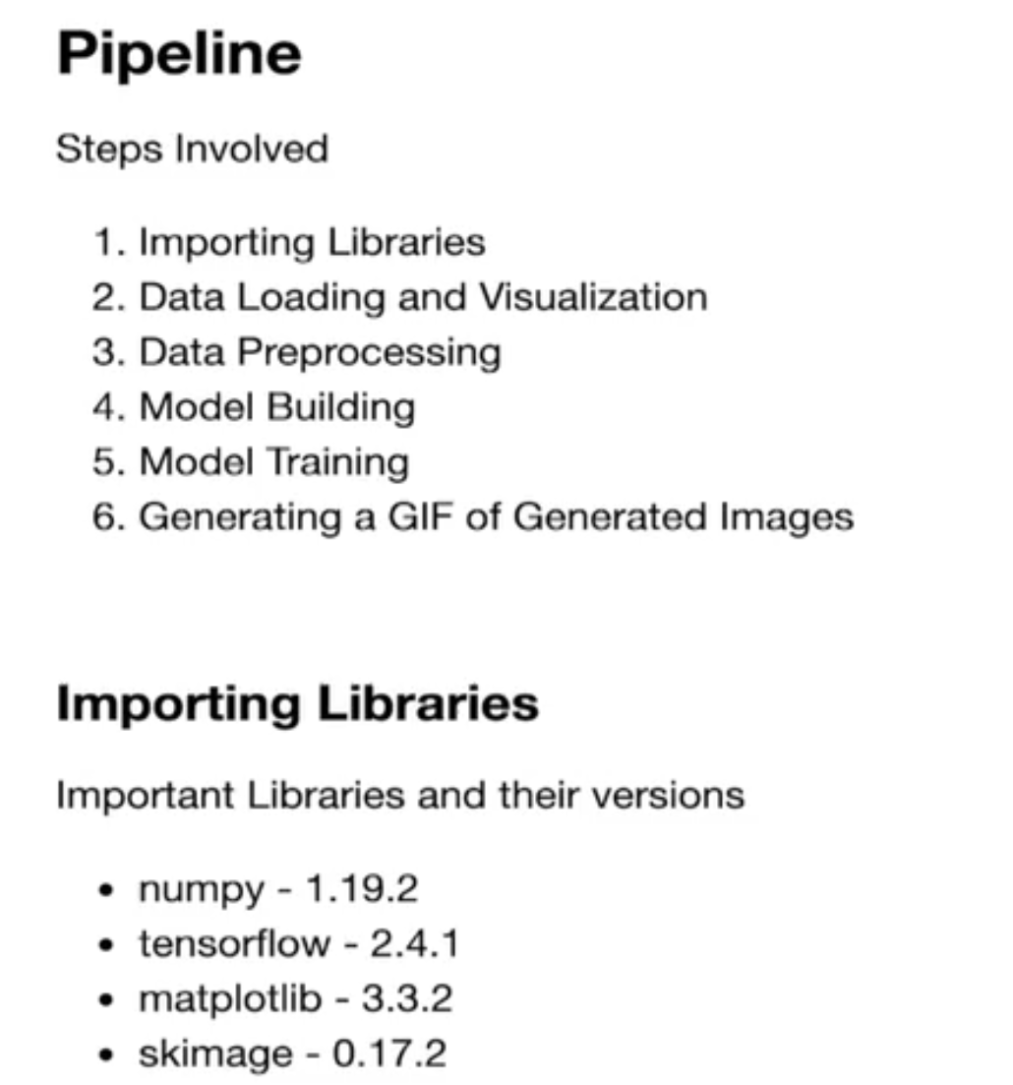

The notebook that we will be using, is attached above.

So far as part of the course content, you have worked with the simple and traditional kind of approach to build a model using the Keras wrapper in Tensorflow. Most of the time the built-in layers and pre-trained models does the job but what if you want to create your own custom models or layers? You can refer to the optional session on **the Custom Model Building** module provided in the resources section to understand the below demonstrations better.

For a better understanding of our notebook, the DCGAN implementation can be divided into six steps. They are as follows:

1. **Importing Libraries**
2. **Data Loading and Visualisation**
3. **Data Preprocessing**
4. **Model Building**
5. **Model Training**
6. **Generating a GIF of Generated Images**

Of the above steps, you have already covered the first one, which is importing libraries.

Important: TensorFlow is a very dynamically changing library, you are advised to follow the same version as mentioned in the notebook for error-free execution.

The versions of some of the important libraries are as follows:

* numpy - 1.19.2
* tensorflow - 2.4.1
* matplotlib - 3.3.2
* skimage - 0.17.2

Therefore, after starting the notebook with what we intend to implement, let's proceed to the next segment.

## Read More

Get more detailed insight into DCGAN implementation [here](https://www.tensorflow.org/tutorials/generative/dcgan).

# DCGAN Demonstration: Data Preprocessing

Now that we imported the required libraries in the previous segment, let’s move on to load the MNIST dataset, which will be used in the following demo.

So we load our data through an inbuilt dataset in TensorFlow, which returns train_images and train_labels as the first tuple. The second tuple contains the test set, which we don't need here. You can read more to the T[ensorFlow official documentation](https://www.tensorflow.org/api_docs/python/tf/keras/datasets/mnist/load_data) to read more about this.

(train_images, train_labels), (_, _) = tf.keras.datasets.mnist.load_data()

Data preprocessing is a common step that is followed after loading the data. One of the important steps while working with image data, is image normalisation. Let’s watch the next video to find out the number of steps that are required to perform data preprocessing.

We normalize the image pixels in range (-1, 1) using the following formula. Dividing raw pixel values of range (0, 255) by 127.5 will make it in the range (0, 2) and when we subtract 1 from all the values, we get (-1, 1).

train_dataset = (train_images/**127.5**)-**1.0**

So we learnt about the sub-steps involved in data preprocessing and performed one of them as well - data normalisation. Let’s go ahead and complete this step.

In the video, we first normalised the data between [-1, 1] for faster training, resized images to [32, 32] and added another dimension as an image channel.

We resize images using an inbuilt function in skimage library. Find the reference to the function [here](https://scikit-image.org/docs/dev/api/skimage.transform.html#resize).

resize(img, (**32**, **32**))

 In the last step, we batch and shuffle the dataset. Refer to [this](https://www.tensorflow.org/api_docs/python/tf/data/Dataset#shuffle) for shuffle and [this](http://www.tensorflow.org/api_docs/python/tf/data/Dataset#batch) for the batch.

train_dataset = tf.data.Dataset.from_tensor_slices(train_images).shuffle(BUFFER_SIZE, seed=**42**).batch(BATCH_SIZE)

Now, our data is ready to be used! But before that, we need to build the GAN model, which will be demonstrated in the next segment.

# DCGAN Demonstration: Model Building

You learnt that GAN is composed of two components - the generator and the discriminator. Let’s take a look at the next video to understand how we can build a generator that uses deep convolution networks in the background. You will also notice how deep convolutional layers are used in upsampling the data, in the next video.

Now that you analysed the working of deep convolutional networks and the concept of generator building, let’s implement the same in code.

We use the following inbuilt Keras layer to implement the [Transposed 2D Convolution](http://www.tensorflow.org/api_docs/python/tf/keras/layers/Conv2DTranspose).

tf.keras.layers.Conv2DTranspose(**128**, (**3**, **3**), strides=(**2**, **2**), use_bias=**False**, padding='same')

After Implementation, let’s visualise the model we have built using the [plot_model function](http://www.tensorflow.org/api_docs/python/tf/keras/utils/plot_model).

plot_model(generator, show_shapes=**True**, show_layer_names=**True**)

We can clearly see that the model uses upsampling to generate images from the noise.

Now let’s see if our generator model is able to predict anything or not. Note that we haven’t trained our model as of yet.

By printing the output of the novice generator you can see that it generates a meaningless image.

Now it’s time to build the discriminator. Let’s see how it’s done.

The discriminator is an image classifier, hence we use [Convolutional layers](http://www.tensorflow.org/api_docs/python/tf/keras/layers/Conv2D) using the following code snippet.

tf.keras.layers.Conv2D(**32**, (**3**, **3**), strides=(**1**, **1**), use_bias=**False**)

# DCGAN Demonstration: Loss and Checkpoint

Loss calculation is a crucial step in model training and both of our models, the discriminator and the generator, have their own losses. Let’s first look at the discriminator loss calculation in the next video.

In the video, you saw that the discriminator, being a classifier, uses [binary cross-entropy](http://www.tensorflow.org/api_docs/python/tf/keras/losses/BinaryCrossentropy) as a loss function.

cross_entropy = tf.keras.losses.BinaryCrossentropy(from_logits=**True**)

It involves two cases for loss computation, wherein one is associated with the real input image and the other is a fake input image produced by the generator.

real_loss = cross_entropy(tf.ones_like(real_output), real_output)

fake_loss = cross_entropy(tf.zeros_like(fake_output), fake_output)

total_loss = real_loss + fake_loss

 In the next video, you will find out that the generator also derives its loss from the discriminator.

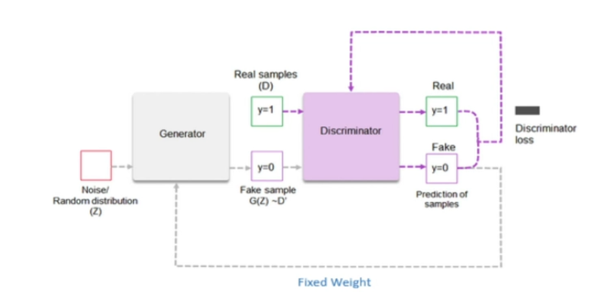

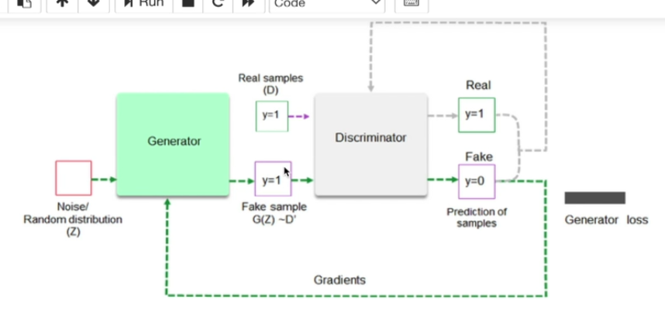

The generator has only one situation where it needs to improve, which is when it fails to fool the discriminator. Since the generator calculates its loss from the discriminator, it also uses binary cross-entropy loss.

cross_entropy(tf.ones_like(fake_output), fake_output)

Now that we have calculated the losses, we need to ensure the initialisation of the optimisers for weight updation of the models. We will also initialise the checkpoints to save the weights of our models to use in the subsequent steps of training.

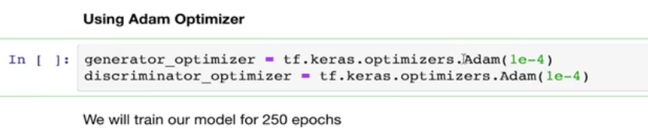

We have [adam optimizers](http://www.tensorflow.org/api_docs/python/tf/keras/optimizers/Adam) for both the components of GAN. We implement the same using the following snippet.

tf.keras.optimizers.Adam(**1e-4**)

# DCGAN Demonstration: Model Training

Before you proceed to train our models for an estimated number of epochs, let’s systematically approach and create a function to train our model for one step. We will call this function while training.

There are two major steps in training any deep learning model - the first one is calculating the loss and the second one is updating the weight and bias of the model using the optimizer. Let’s first see how we calculate the loss for the generator and the discriminator.

We initialise the [gradient tapes](http://www.tensorflow.org/api_docs/python/tf/GradientTape) for the generator and discriminator for auto calculation of gradients. It is accomplished by the following code.

tf.GradientTape() **as** gen_tape, tf.GradientTape() **as** disc_tape

Now the next remaining step in the training is to calculate and apply the gradients on the model using the loss we just calculated.

To calculate the gradients we just need to call the gradient tape functions, we initialised earlier. For example, we call the following method for the generator. ([Reference](https://www.tensorflow.org/api_docs/python/tf/keras/optimizers/Optimizer))

gen_tape.gradient(gen_loss, generator.trainable_variables)

After calculating the gradients we also need to apply the gradients on the [optimizers](http://www.tensorflow.org/api_docs/python/tf/keras/optimizers/Optimizer) to update the model’s weight and biases.

generator_optimizer.apply_gradients(zip(gradients_of_generator, generator.trainable_variables))

In the next video, you will understand that you just need to call the function that you created earlier to perform one batch of training. It provides us with better comprehension and easier code management.

We train our model for a certain number of epochs. For each epoch, we have several batches of images, which we pass through training flow one by one. Note that we are calling the train_step function we defined in the previous step.

**for** epoch **in** range(**1**, EPOCHS+**1**):

**for** image_batch **in** train_dataset:

train_step(image_batch)

# DCGAN Demonstration: Conclusion

As of now, we have trained the generator and also printed the images that it generates. You also realised that the generator gets better as the training progresses.

For a better understanding of the progress of this improvement, let’s generate a GIF of output images that was generated by the generator.

Looking at GIF, we can say that our generator improves itself really fast and is able to generate almost realistic images at the end.



This concludes our session on the basics of GAN and DCGAN implementation. You are now capable of building your own GAN model for the common use cases, where you are required to generate new images of a dataset. Isn’t it amazing!

Now you have the dataset (refer to segment 2) and the understanding of DCGAN implementation. You can find the T1 dataset inside the dataset provided in segment 2. To reinforce your understanding, you are encouraged to solve a subproblem of generating T1 MRI images from the noise before going into the next session.

# Summary

So far, you learnt about the concept of GANs, their working and implementation. Now, let’s summarise your learnings from this session:

1. Getting T1 and T2 MRIs both done is **expensive and time-consuming**. Hence, generating T2 MRIs from T1 MRIs will **save time and money**.
2. There are various fields where GANs are already being used, such as:
   * Generating fashion
   * Making deep fakes
   * Enhancing the low-resolution pictures to high resolution
3. Architecture of GANs
   * GAN has two components - The generator and the discriminator
   * The generator takes **noise input** and tries to **convert it into a realistic-looking output**, whereas the discriminator tries to **classify input data into real or fake**.
   * The generator is a **de convolutional neural network** and the discriminator is a traditional classifier **convolutional neural network** (CNN) when you use GAN to generate images.
   * Both the components force each other to become better, thus working as adversaries.

DCGAN is the same as traditional GAN, except that it generates images by using de convolutional networks.

# Image to Image Translation and CycleGAN

# Introduction

Welcome to the second session of the capstone ‘**Style Transfer using GAN**’.

In the previous sessions, you learnt about theoretical aspect of basic GAN, which takes noise as input and produces an output image. Your understanding of GAN was also reinforced by implementing DCGAN (Deep Convolutional Generative Adversarial Network) to generate MNIST digits as shown below.



Here, your goal is to transfer the style of one MRI image into another, which is unlike basic GAN. More precisely, you want to be able to generate an output image giving an input image.

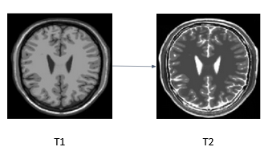

Remember that you used to give noise input in DCGAN? Can you simply replace that noise with an image, while keeping everything else the same? Or do you need some changes in the architecture as well? You will find answers to all these questions in this session.

Let’s list all the key learnings we will cover in this session:

* Overview of Image-to-Image Translation
* Overview of CycleGAN and its Applications
* CycleGAN Architecture and Training
* Types of Loss in CycleGAN
* Code Demonstration of CycleGAN

# Introduction to Image to Image Translation

In the previous segment, you learnt about GAN models that can take noise as input and convert it to an image. But what you eventually want to do is to convert T1 MRI images into T2 MRI images. Hence, the ideal model would convert images of one domain to that of another domain, and in this case, those two domains would be T1 and T2.

So how do you translate an image of one domain to another? Welcome to the world of **image-to-image translation**. Snehansu will introduce this awesome technology to you in the video below.

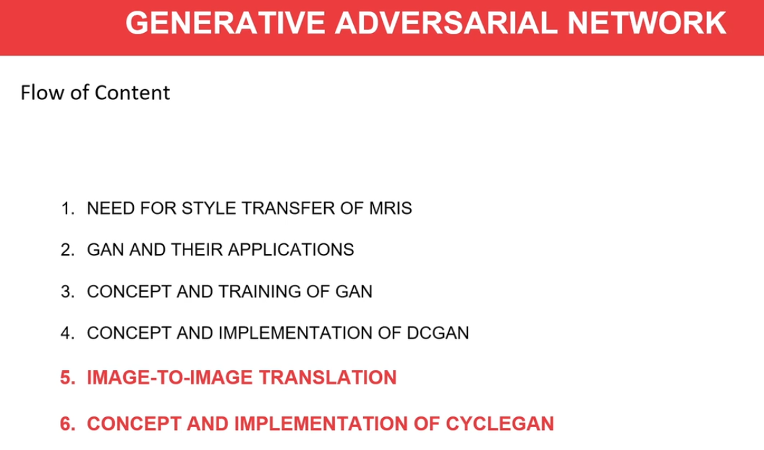



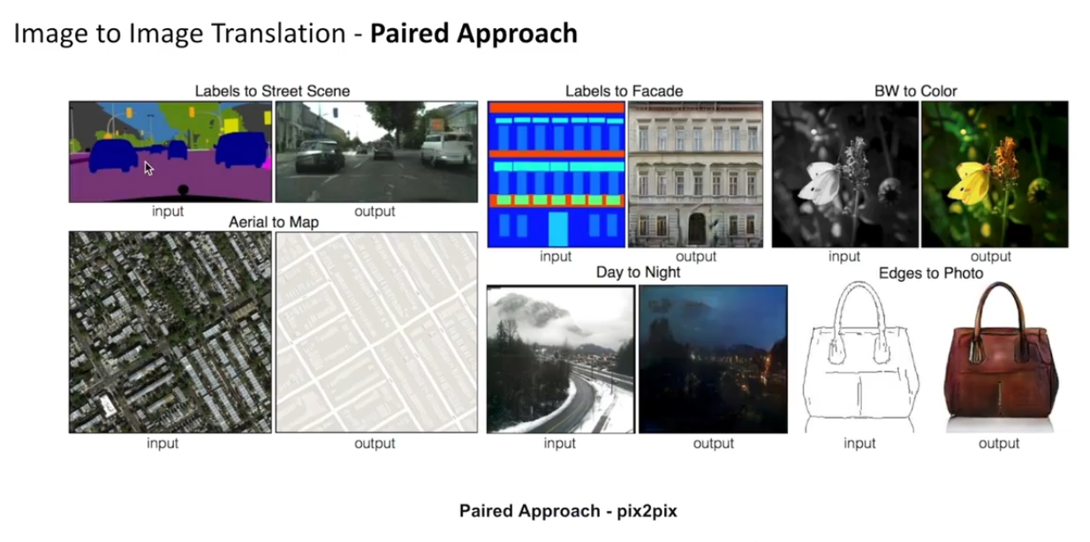

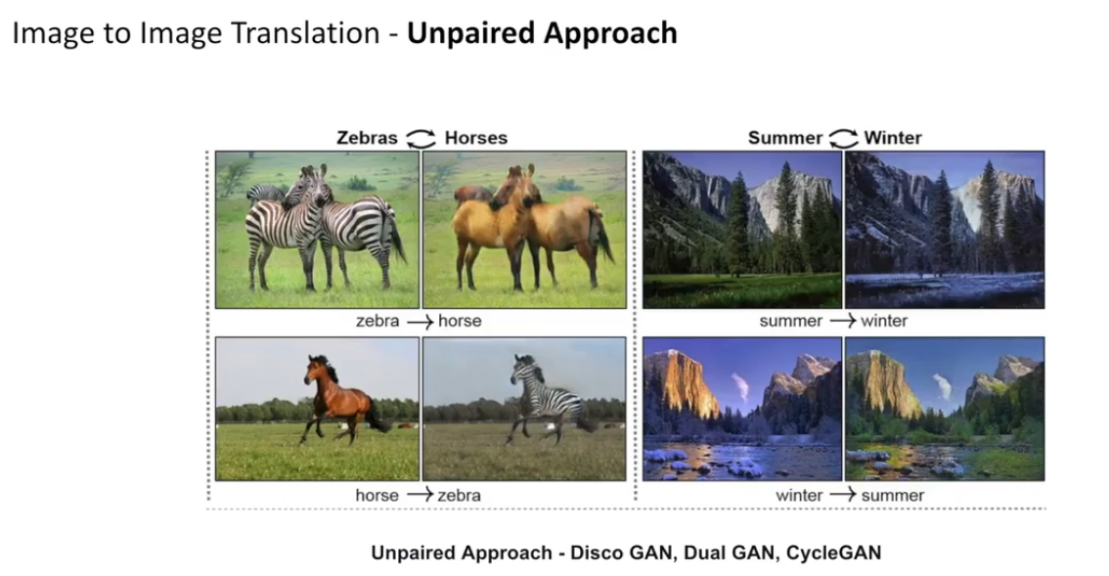

The image-to-image translation is of two types based on the type of data used: paired and unpaired.

**Paired Data:** Here, natural mapping is possible between input and output images or you have the exact mapped output image available for each input image.

For example, you have a street map to satellite map translation or sketch to actual image translation as shown in the image below.

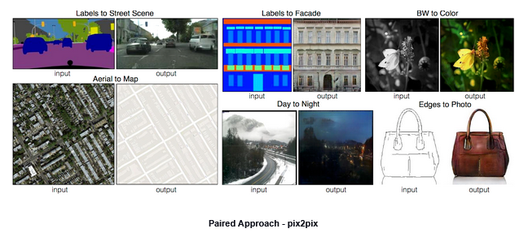

For this kind of translation, **pix2pix architecture** is used.

**Unpaired Data:** Unpaired data is also called **independent data**, where there is no unique relationship between the input image and the output image.  For example, let’s consider the horse to zebra style transfer. Here, a direct mapping is not possible because a horse cannot simultaneously exist as a zebra and vice versa.

Another similar example is weather translation of images, where a place cannot **experience two different kinds of weather** at the same time. Suppose there is a tree in an image. It would look different as the weather changes. In autumn there would be fewer leaves; the leaves might have a reddish shade in summer; in winter, the same tree might appear hazy due to fog. Each image of the tree may have different features thus showing the different weather conditions.

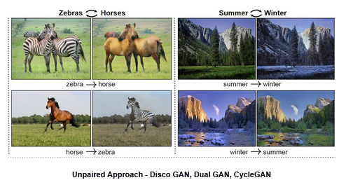

For the unpaired approach of Image to Image translation, you have **CycleGAN, DualGAN and DiscoGAN**.

**The advantage of the unpaired approach** is that you do not need to have the label for input images. Two independent domains can also be mapped with this approach. Our problem lies inside the unpaired approach since acquiring both types of MRIs as paired dataset is expensive and involves too much time. This is expensive because both the MRIs should be done every time even when only one of them is needed, and time-consuming because finding out which two MRIs might have been taken at the same time is very difficult.

You will be using CycleGAN to solve the problem statement with the unpaired dataset that will be provided to you while implementing the project in the next session.

# CycleGAN Overview and Its Applications

Now we know that CycleGAN is used for generating images of a domain from another domain. But the question remains what enables its generator to create images of a domain from another domain. Let’s see what Snehanshu wants to say about it.

So the functionality of the generator changes from DCGAN to CycleGAN. In DCGAN we create images from one-dimensional noise input, whereas in CycleGAN, our aim is to generate images from a different domain of images.

This image-to-image translation becomes possible because of an architecture called U-net. Have a look at the below image of U-net architecture.

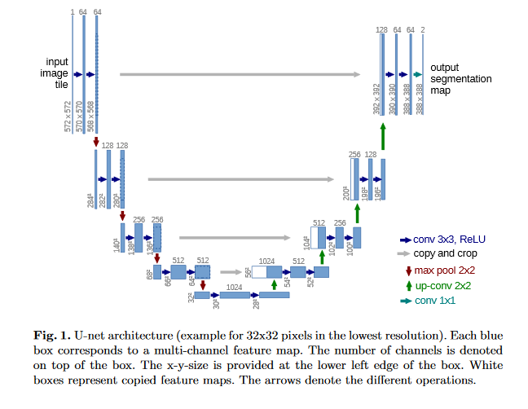

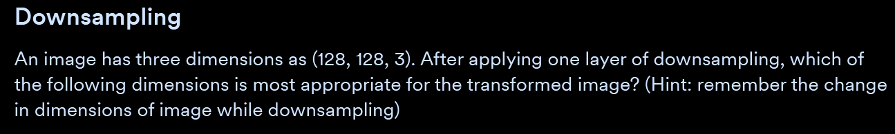

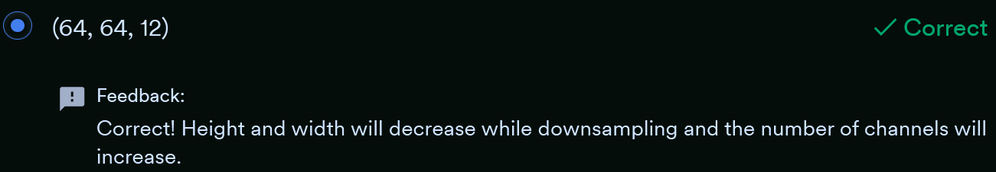

Notice how in U-net, we are first compressing the image into low dimensions and then expanding it to achieve the output image. The first compressing step is called **downsampling** and the second step is called **upsampling**.

There are also direct connections between layers of upsampling and downsampling as you can see in the image. These connections are called **skip connections**. These connections ensure the transfer of **static components** of the images such as the background. To understand the same, have a look at the below picture, notice that the background is not changing, hence we can map it directly using skip connections.

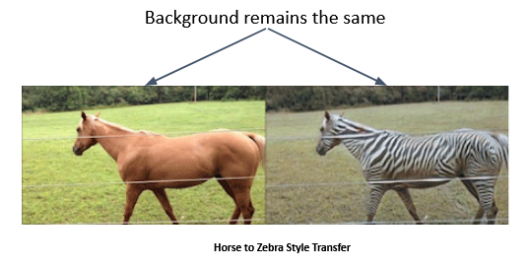

Having understood the use of CycleGAN, let’s see a few more use cases of CycleGAN.

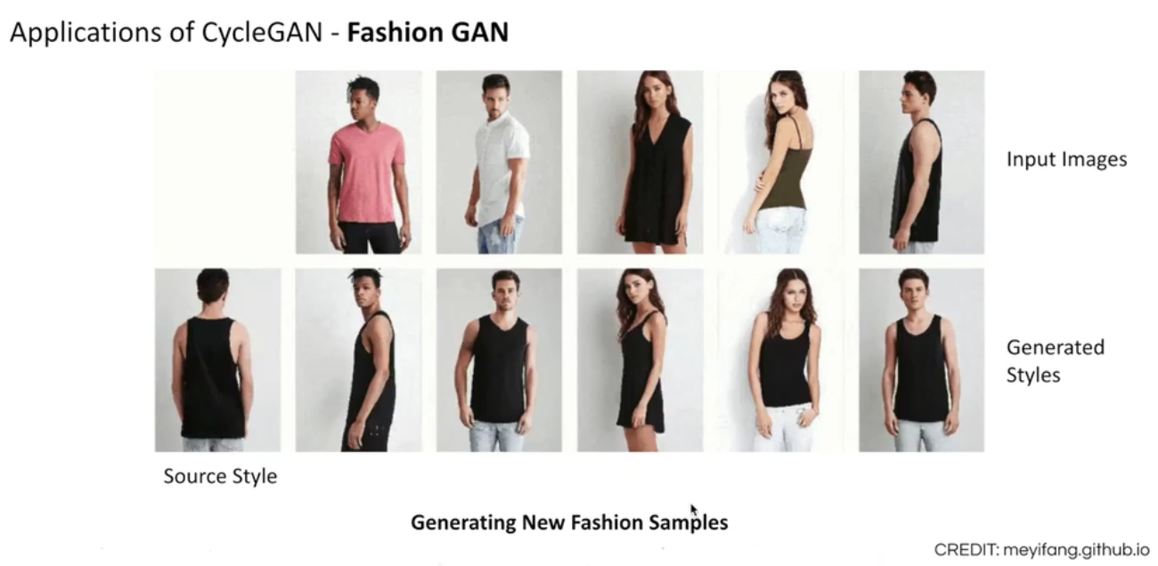

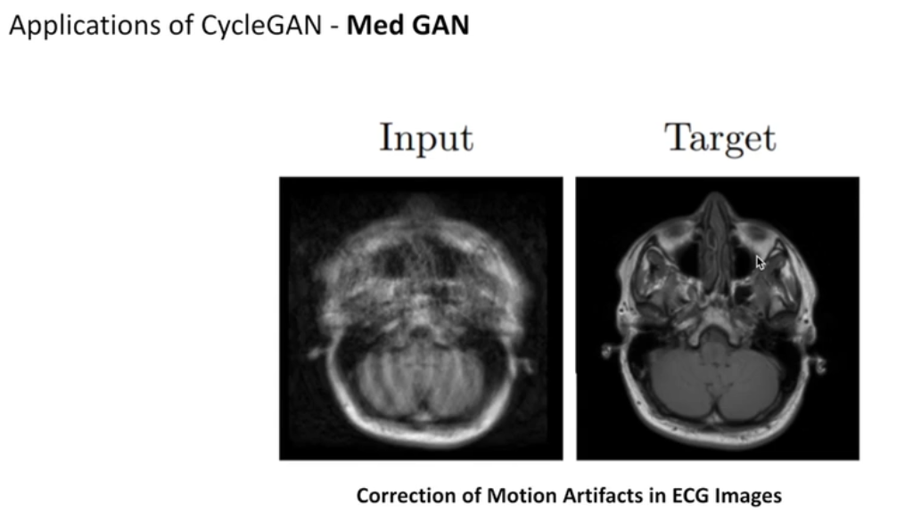

Fashion GAN and Med GAN are also variants of CycleGAN with specific use cases. Fashion GAN is a fine example of CycleGAN, where we generate various new never seen before styles from learnt data. The correction of motion artefacts in medical images is a domain translation problem from motion-corrupted images into motion-free images, which is also inspired by CycleGAN.

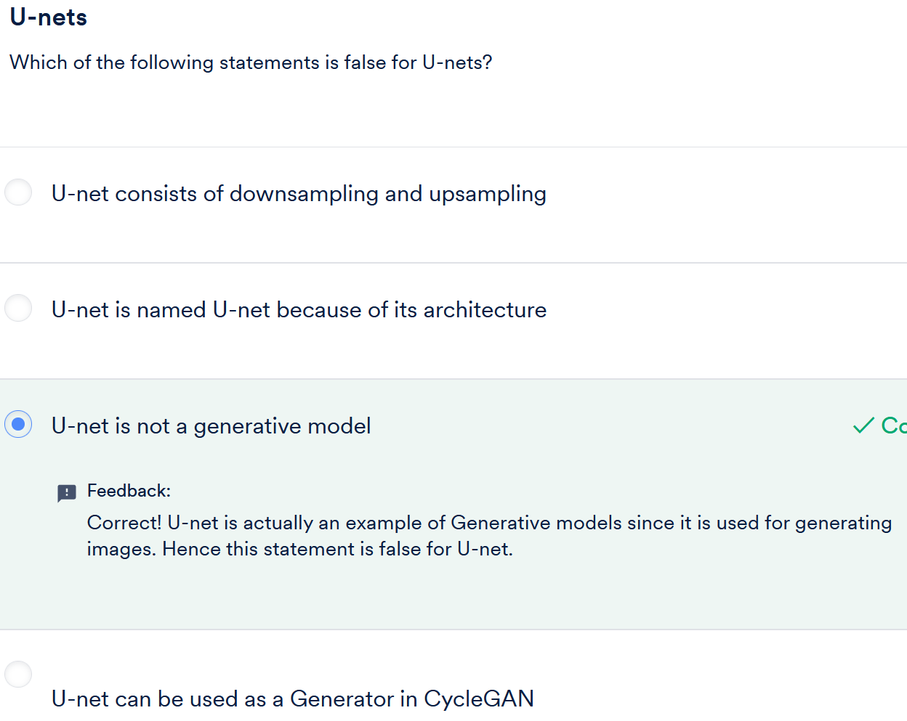

# CycleGAN Architecture and Training

Now that we understand what types of problems are solvable by CycleGAN, let’s have a look at what architecture enables it to work so efficiently.

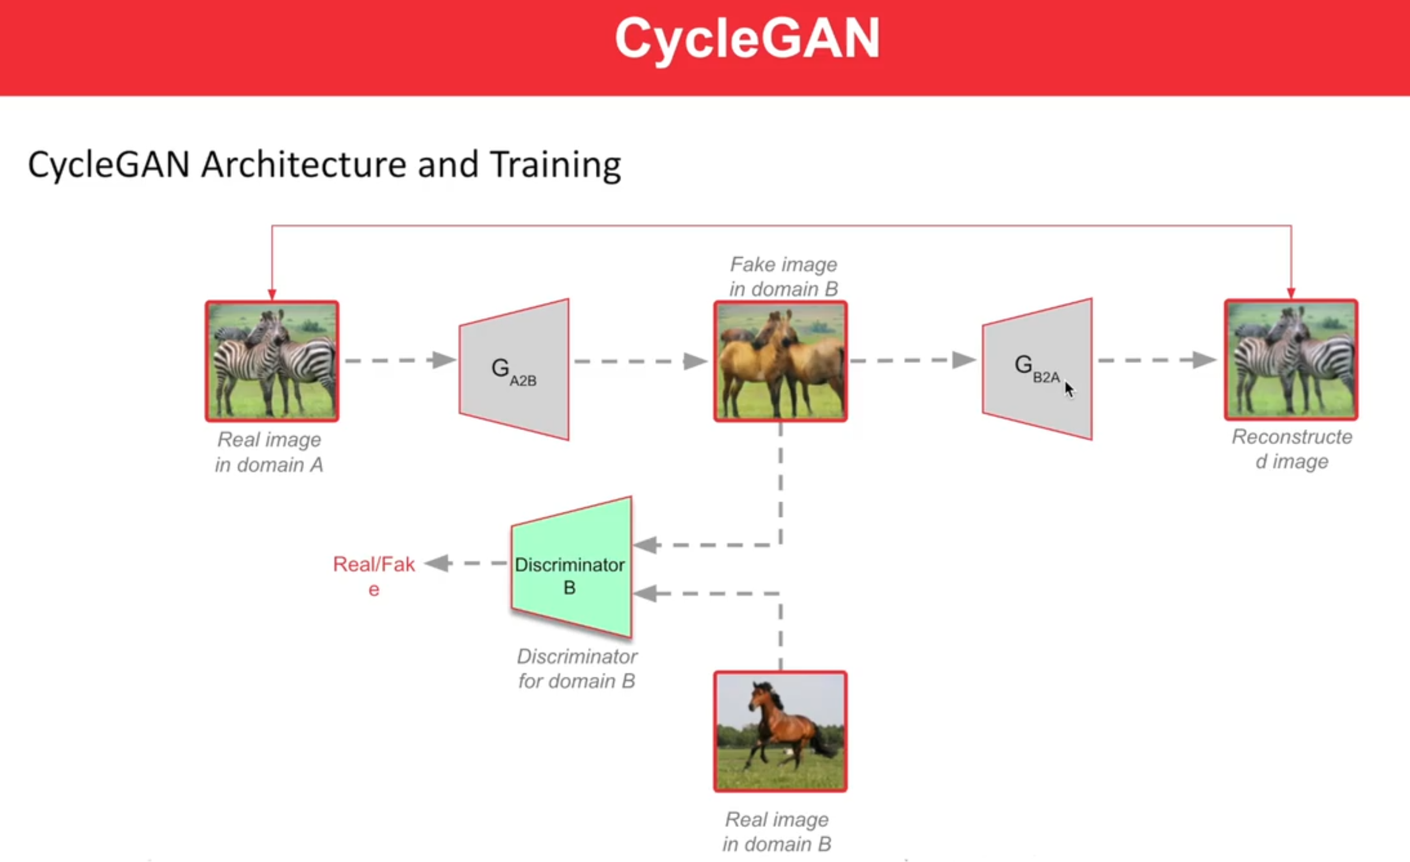

So CycleGAN consists of two Generators, transforming one domain into another and vice versa. Remember that we are dealing with two domains here, like in the case of horse to zebra style transfer, we have a horse domain and a zebra domain.

A domain can be a particular group of objects with similar characteristics, for example, all horses have the same physical characteristics, hence they can form a domain. Similarly, the zebra domain is for the zebras. When we say style transfer, we are interested in transferring the characteristics of domains.

In CycleGAN, one of the generators converts images from one domain (x) to another domain (y) whereas the other generator reverses this operation by converting from y to x.

Now consider converting x to y using a generator and then again y to x using another generator, this completes a cycle, and that’s how this name, CycleGAN, came into existence. We will learn more about these cycles later in this segment.

But why do we need a discriminator can’t we just have a U-net and do image-to-image translation without the discriminator?

So we were not having the discriminators from the beginning of image-to-image translation, but without the discriminators, we had to use L1 or L2 loss for training, which didn’t fetch good results.

Why did L1 and L2 losses fail? Because they depend on the natural mapping of input images by taking pixel by pixel difference, which doesn't develop domain understanding. Suppose you are given images of two domains, now mapping both images using direct L1 or L2 loss would lead to very hard mapping, where no understanding of the domains is involved. This leads to a very blurry transformation of the input image.

For example, if we directly map horse to zebra using L1 to L2 loss, our model would understand that we want strips in the output image, but positioning of the strips will not be clear, for which proper domain understanding is required.

When we use the discriminator for calculating loss, our generator is forced to learn the characteristics of the domain, which leads to better results.

Discriminators have been a revelation! Discriminators are the reason behind the robust learning of the generators, as Snehansu explained.

Now let’s have a look at another side of the story, by looking at another cycle involved in CycleGAN.

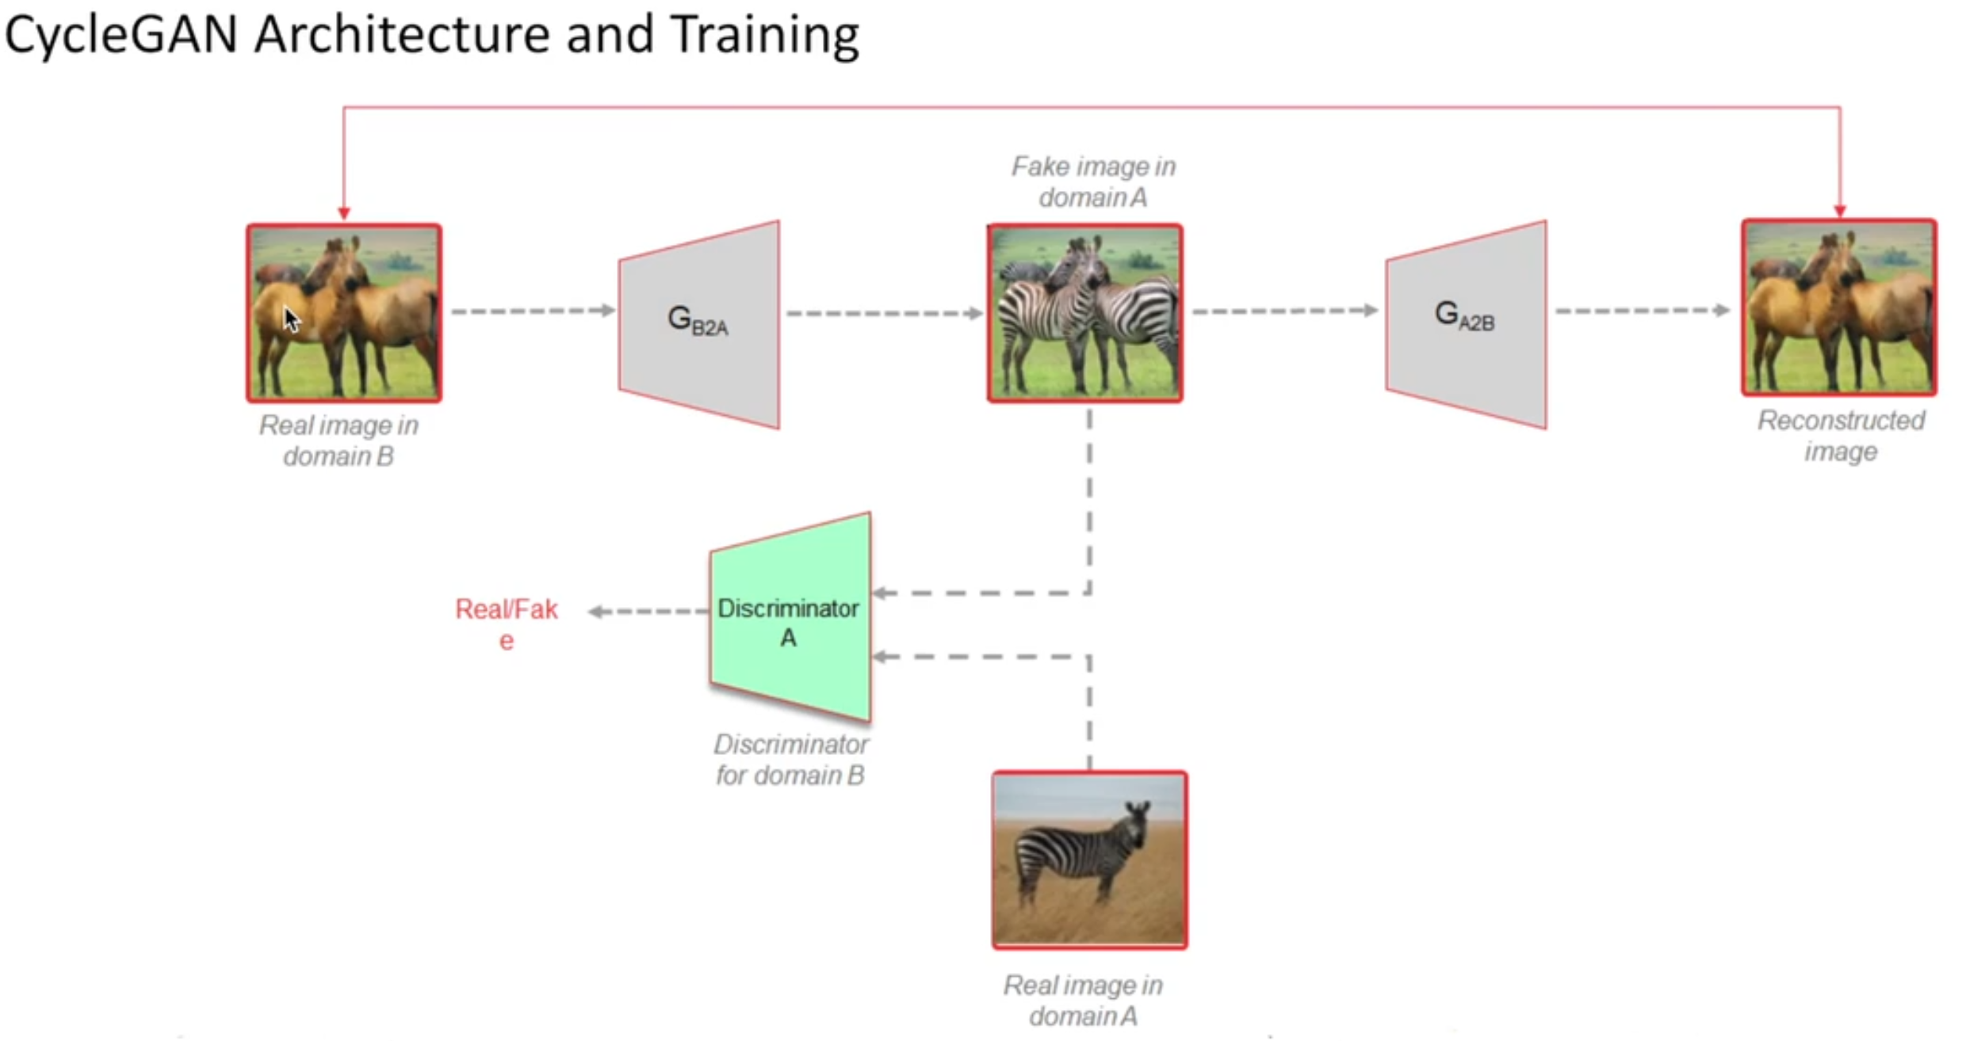

So there are overall two cycles in CycleGAN. Previously we discussed the cycle x→ y→ x.

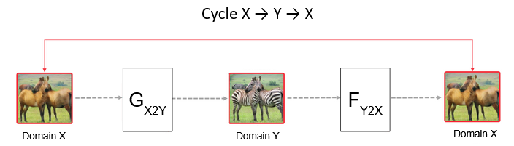

On the same lines we also have y→ x→ y.

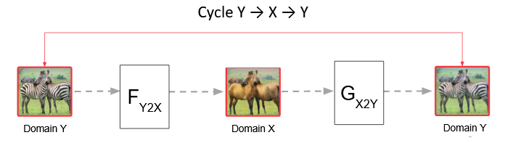

We also have two discriminators and each domain is associated with their respective discriminators, which have the responsibility of assigning the images of their domain to real and other images as fake. You’ll get a better understanding of this in the next video.

Both the generators are trained along with their respective discriminators. Let’s understand the full flow of training in CycleGAN

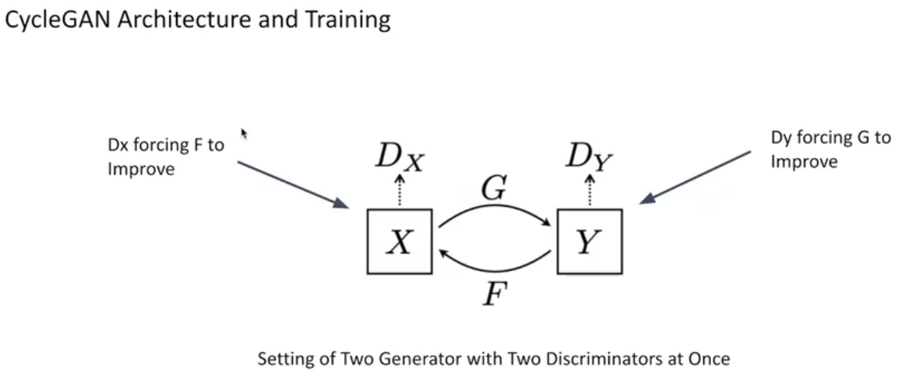

So we saw that CycleGAN is basically equivalent to two GANs working together, where each GAN has its own set of the generator and the discriminator. Overall there are two generators and two discriminators.

# Loss Functions in CycleGAN

You have seen the flow of training for CycleGAN and know that CycleGAN consists of a different kind of generator than that of DCGAN, but does that change the loss functions as well? Let’s find out in the next video.

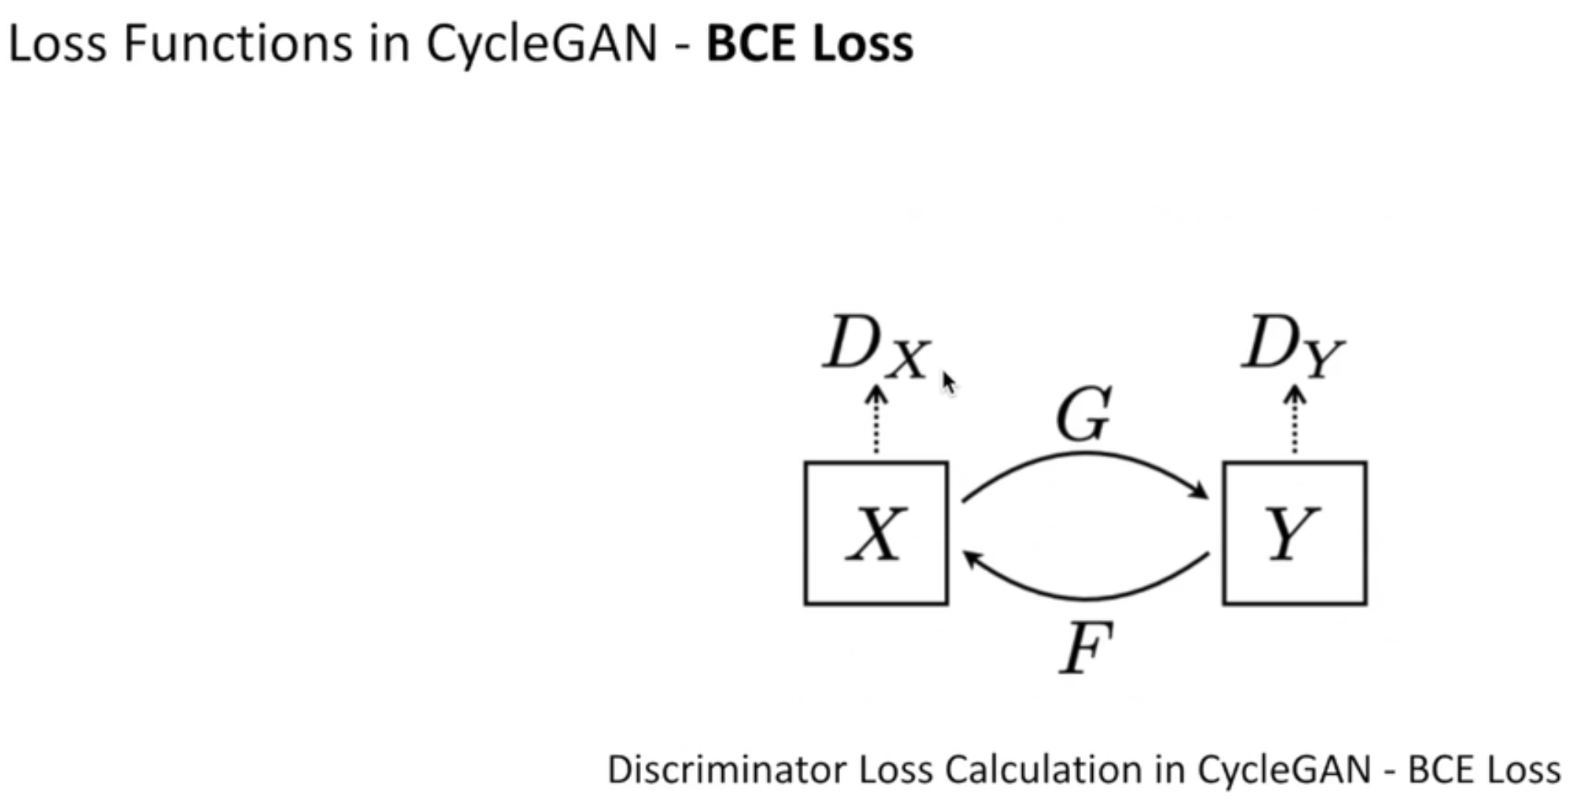

In this video, you saw that BCE loss exists even in CycleGAN, although the instances of BCE loss are the same as DCGAN for both generator and discriminator. Discriminator has BCE loss for both  real and fake data, whereas the generator gets BCE loss only for fake data.

Let’s find out about other losses which one needs to consider while working with CycleGAN.

So there are two additional losses that we have in CycleGAN, both are only for the generator training.

**Cycle Consistency Loss**: Since there are two generators, they might be used back to back to regenerate the image in the same domain. Suppose, F converts from zebra (Y) to horse (X) and G converts from horse (X) to zebra (Y). DX corresponds to the discriminator in the X domain, whereas DY corresponds to the discriminator in the Y domain, as shown in the following image.

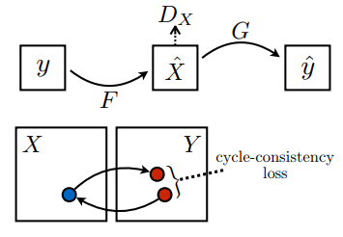

Now, if we input a zebra Image in F, get a new fake output image and then again apply the generator G on the same output image obtained from F, we will get the image in the same domain of zebra. Intuitively, this image should be equivalent to the original image that was sent to F as an input, this loss is calculated as **cycle consistency loss**. This loss is calculated by taking the L1 difference between the images, which is a mean absolute difference between pixels of both images.

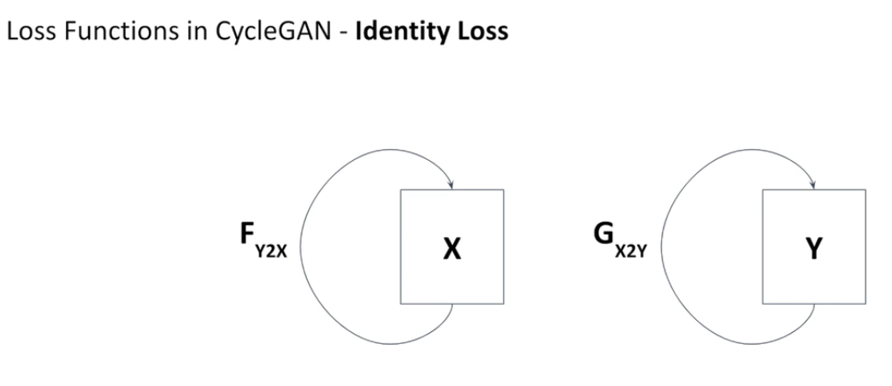

**Identity Loss** - Let’s consider a case - If we provide an input image of a zebra to the G (horse to zebra) generator, it should produce the same zebra image without any changes. Any difference between both these images is called Identity Loss, which is calculated as an L1 loss.

# CycleGAN Demo: Introduction

So far, we’ve acquired a grasp on the theoretical understanding of CycleGAN. Considering the final goal of our capstone, from this lecture onwards we’ll learn about the implementation of CycleGAN.

First of all, Snehansu will introduce the problem statement that we’re going to solve in the CycleGAN demonstration.

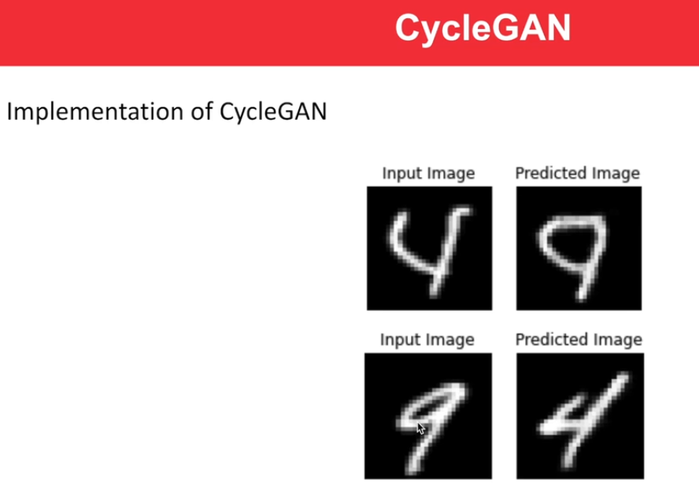

So we will use the MNIST data set and our objective will be to convert images from the digit 4 domain to the digit 9 domain and vice versa.

Going forward we will follow the notebook given below.

As we discussed in the video, we’ll be implementing MNIST digits conversion from 4 to 9 and vice versa and our pipeline for this demonstration will be the following:

1. Importing Libraries
2. Data Loading and Visualisation
3. Data Preprocessing
4. Model Building
5. Model Training
6. Generating a GIF

So after knowing what we are going to implement and importing libraries we’re all set to move ahead in our pipeline in the next lectures.

# CycleGAN Demo: Data Loading and Preprocessing

Let’s start this session by loading MNIST data and visualising it.

So, you saw that you only need to have data corresponding to digits 4 and 9 for your use.

img4 = train_images[train_labels == **4**]

img9 = train_images[train_labels == **9**]

You also saw that the label assigned to images is corresponding to the actual digits in the images. There are 5842 images corresponding to digit 4 and 5949 images corresponding to digit 9. Each image is of size (28, 28).

Now the next step is **data preprocessing.**

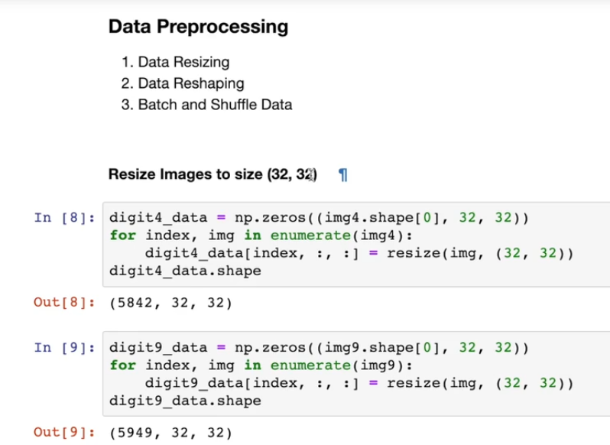

There are various operations under data preprocessing such as normalization pixels, resize, reshape, shuffle and store in batches.

You have already performed normalisation just after loading the data in the range [-1, 1]. It helps the models to learn faster.

img4 = (img4/**127.5**)-**1.0**

Resizing to (32, 32) is done for convenience in model making and it also helps in making GPU operations faster by making the dimensions as a power of 2.

resize(img, (**32**, **32**))

Images are reshaped by adding one more dimension as a channel since neural networks expect images to be three-dimensional objects (height, width, channel). The data type is converted to float for convenience of precision while dividing and multiplying with weights of the model.

digit4_data.reshape(digit4_data.shape[**0**], **32**, **32**, **1**).astype('float32')

# CycleGAN Demo: Model Building

In an earlier demonstration of DCGAN to generate MNIST images, you saw that a deconvolutional network is required for generators and a convolutional neural network (CNN) for discriminators, but as you have seen already in previous lectures, your generator will be a bit different because it would have a U-net in its core.

You will also have a new type of layer in your models called the Instance Normalization layer, which contributes significantly to the efficient learning of the models. Let’s hear about it from Snehansu.

So, instance normalization is nothing but a batch normalization applied individually for each image. You need to call [tf.nn.moments](https://www.tensorflow.org/api_docs/python/tf/nn/moments) with axes=[1,2] to compute the mean and variance according to instance normalization.

mean, variance = tf.nn.moments(x, axes=[**1**, **2**], keepdims=**True**)

inv = tf.math.rsqrt(variance + self.epsilon)

normalized = (x - mean) * inv

[tf.math.rsqrt](https://www.tensorflow.org/api_docs/python/tf/math/rsqrt) is a function used for taking the inverse square root of the value (here of variance). Hence, in the last expression, when multiplying with inv, you are actually multiplying by 1/stddev. Hence, the actual formula of normalization remains the same as

**(x−mean)/standarddeviation.**

Suppose image x has three channels. Then for each channel, you will have a mean and variance as you can also see in the picture given below.

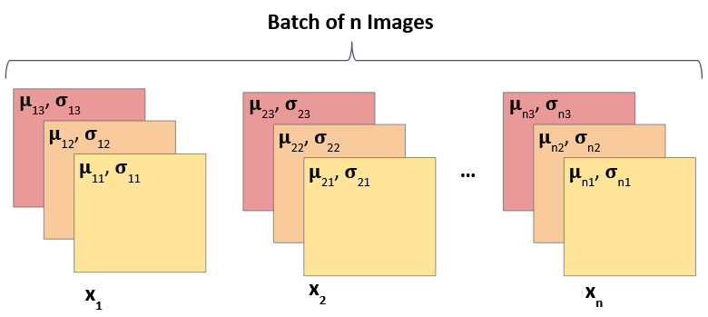

To make up for the loss in representational capability because of normalization, there are two learnable parameters, scale (gamma) and offset (beta).

self.scale * normalized + self.offset

For more information, look at [Normalizations](https://www.tensorflow.org/addons/tutorials/layers_normalizations).

After defining your instance normalization layer, you need to have a look at how a generator in CycleGAN takes the form of U-net architecture. Let’s learn more about this in the next video.

Basically U-nets are very similar to encoder-decoder architecture, which involves downsampling and upsampling respectively.

[Convolutional layers](https://www.tensorflow.org/api_docs/python/tf/keras/layers/Conv2D) are used while implementing downsampling.

tf.keras.layers.Conv2D(filters, size, strides=**2**, padding='same', kernel_initializer=initializer, use_bias=**False**)

For upsampling, [transposed convolutional layers](http://www.tensorflow.org/api_docs/python/tf/keras/layers/Conv2DTranspose) are used.

tf.keras.layers.Conv2DTranspose(filters, size, strides=**2**, padding='same',

kernel_initializer=initializer,use_bias=**False**)

**Skip connections** are introduced for capturing the static elements of an image such as background, which can be mapped directly to the output image. Hence we connect downsampling layers with upsampling layers via direct connections as well. The bottleneck downsampling layer doesn’t have any skip connection as you can see in the unet image.

Both the generators in the CycleGAN model will be U-nets. So, let’s implement the generator on the same lines.

So, you built both the generators following the same architecture. You also used model.summary() to display the architecture, where you can clearly see how the image dimensions (height and width) are first decreased from (32, 32, 1) to (1, 1, 128), and then increased to form the output image of size (32, 32, 1). The input of each layer goes through the instance normalization layer that you defined earlier.

**For establishing skip connections**, first store all the downsampling layers in a list.

skips = []

**for** down **in** down_stack:

x = down(x)

skips.append(x)

These skip connections are reversed because the second last downsampling layer should connect with the first upsampling layer. Note that in the U-net image, the last downsampling layer has no skip connections as it is a bottleneck layer. Now, you have to use these reverse skips to connect while using upsampling layers through the concat() function.

skips = reversed(skips[:-**1**])

**for** up, skip **in** zip(up_stack, skips):

x = up(x)

x = concat([x, skip])

Now, the discriminator will be the same as the one used in DCGAN because the functionality has remained the same. The only change is that there are two discriminators here, which will again follow the same architecture as convolutional neural networks (CNN).

As you saw, the discriminator has only downsampling layers. Here, downsample is just a set of layers including Conv2D + Instance Norm + Leaky Relu for downsampling the input.

down1 = downsample(**64**, **4**, **False**)(x)

You can also put a few pure Convolutional layers in the discriminator.

tf.keras.layers.Conv2D(**256**, **4**, strides=**1**, kernel_initializer=initializer,

use_bias=**False**)(zero_pad1)

By printing model.summary(), you would get an even better understanding.

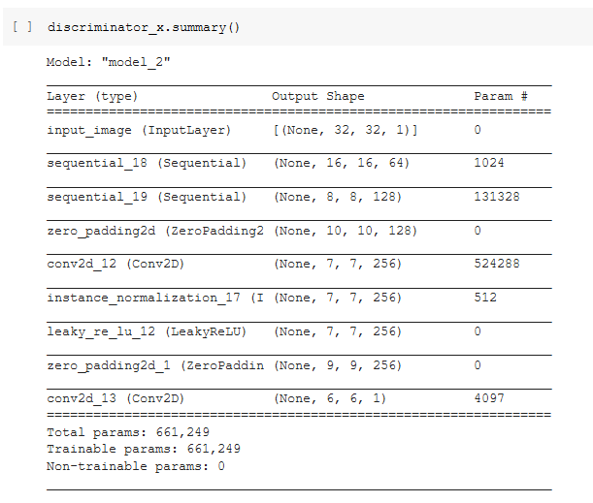

In the ‘Output Shape’ column of the model summary given above, you can see that the height and width dimensions are decreasing as you go from input to output. The output of dimension (6, 6, 1) is a patch of the image, which are averaged out to get the final output. Read more about it [here](https://arxiv.org/pdf/1611.07004.pdf).

# CycleGAN Demo: Loss Calculation and Checkpoint

Now that we have built our models, they are ready for training. Training also requires a lot of pre steps such as loss declaration, optimizer declaration, checkpoint initialization etc.

These are the following subsets within the model training step:

1. Declare Loss type
2. Calculate Discriminator Loss
3. Calculate Generator Loss
4. Cycle Loss
5. Identity Loss
6. Optimizer
7. Checkpoint Initialisation
8. Training Flow

Let’s go ahead and implement them one by one, starting with loss functions.

As discussed, the discriminator remained the same as the DCGAN discriminator, hence the loss calculation will again be the same, i.e., [Binary cross entropy loss](https://www.tensorflow.org/api_docs/python/tf/keras/losses/BinaryCrossentropy).

loss_obj = tf.keras.losses.BinaryCrossentropy(from_logits=**True**)

The discriminator has two instances of loss similar to the DCGAN.

real_loss = loss_obj(tf.ones_like(real), real)

generated_loss = loss_obj(tf.zeros_like(generated), generated)

total_disc_loss = real_loss + generated_loss

Whereas the generator is now a U-net, converting one image into another. Hence apart from discriminator derived loss, there are two more kinds of loss: Cycle Loss and Identity loss, and both of them are calculated comparing input and output images as L1 loss.

Let’s have a look at Cycle Consistency loss. Here, [tf.reduce_mean](http://www.tensorflow.org/api_docs/python/tf/math/reduce_mean) is used for averaging out all the values present in the input.

loss1 = tf.reduce_mean(tf.abs(real_image - cycled_image))

**return** **10.0** * loss1

Now, let’s see the implementation of Identity loss.

loss = tf.reduce_mean(tf.abs(real_image - same_image))

**return** **0.5** * loss

There are weights assigned to each kind of loss, which determines the extent of training of the generator. In the code snippet shown above, you have a weightage of 10 for Cycle loss and 0.5 for Identity loss. It is a parameter and can be changed according to the hypothesis of the programmer. For example, if the model makes lots of errors while calculating the identity loss, it can be corrected by increasing the weight associated with the model.

Now, let’s discuss the checkpoint initialization, which is a crucial stage for model training, especially if the training is very time-consuming.

The optimizer is declared to be Adam, which is effective for faster convergence. Since you have four models in CycleGAN, you will have a separate optimizer for each of them.

generator_g_optimizer = tf.keras.optimizers.Adam(**2e-4**, beta_1=**0.5**)

generator_f_optimizer = tf.keras.optimizers.Adam(**2e-4**, beta_1=**0.5**)

discriminator_x_optimizer = tf.keras.optimizers.Adam(**2e-4**, beta_1=**0.5**)

discriminator_y_optimizer = tf.keras.optimizers.Adam(**2e-4**, beta_1=**0.5**)

You can have a detailed understanding of the parameters passed at the link given below. [tf.keras.optimizers.Adam](https://www.tensorflow.org/api_docs/python/tf/keras/optimizers/Adam).

Checkpoint initialization ensures that you save your model of the three latest epochs, so that you do not have to train the model from scratch every time.

# CycleGAN Demo: Training Flow and Result

Now that you have defined all the essential elements of model training like loss function, optimizer etc., let’s have a look at the training flow for a single batch of images.

As you saw through the code, the training flow of one batch of images will be following -

1. Generate Fake Y and Cycled X
   1. **fake_y = generator_g(real_x, training=True)**
   2. **cycled_x = generator_f(fake_y, training=True)**
2. Generate Fake X and Cycled Y
   1. **fake_x = generator_f(real_y, training=True)**
   2. **cycled_y = generator_g(fake_x, training=True)**
3. Generate Fake Images through G and F for Identity Loss.
   1. **same_x = generator_f(real_x, training=True)**
   2. **same_y = generator_g(real_y, training=True)**
4. Calculate Discriminator prediction using DX and DY on real and fake data for loss calculation.
   1. **disc_real_x = discriminator_x(real_x, training=True)**
   2. **disc_real_y = discriminator_y(real_y, training=True)**
   3. **disc_fake_x = discriminator_x(fake_x, training=True)**
   4. **disc_fake_y = discriminator_y(fake_y, training=True)**
5. Calculate Generator Loss on Discriminator.
   1. **gen_g_loss = generator_loss(disc_fake_y)**
   2. **gen_f_loss = generator_loss(disc_fake_x)**
6. Calculate Cycled Loss on Cycled Images from step 1 and 2.
   1. **total_cycle_loss = calc_cycle_loss(real_x, cycled_x) + calc_cycle_loss(real_y, cycled_y)**
7. Calculate Total Generator Loss →  Disc Loss + Cycled Loss + Identity Loss.
   1. **total_gen_g_loss = gen_g_loss + total_cycle_loss + identity_loss(real_y, same_y)**
   2. **total_gen_f_loss = gen_f_loss + total_cycle_loss + identity_loss(real_x, same_x)**
8. Calculate Discriminator Loss on both Fake and Real Images for Disc X and Y for Disc Training.
   1. **disc_x_loss = discriminator_loss(disc_real_x, disc_fake_x)**
   2. **disc_y_loss = discriminator_loss(disc_real_y, disc_fake_y)**
9. Calculate the Gradients and update the weight and bias of models using the below format.
   1. **generator_g_gradients = tape.gradient(total_gen_g_loss, generator_g.trainable_variables)**
   2. **generator_g_optimizer.apply_gradients(zip(generator_g_gradients, generator_g.trainable_variables))**

This flow will be repeated for all the batches of the data for the estimated number of epochs, as you will see in the next video.

You need to call the above function each time we train our models on a batch of images. For each epoch, we monitor the quality of images generated by the generator displaying the images.

**for** epoch **in** range(**1**, EPOCHS+**1**)

**for** image_x, image_y **in** tf.data.Dataset.zip((digit4_data, digit9_data)):

train_step(image_x, image_y)

You would find out that your models become better and better at generating images as training progresses.

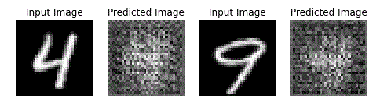

For better visualisation of the training of the generators, we make a GIF of all the images output by them.

The created GIF demonstrates the quick and effective learning prowess of GANs.

# Summary

This segment concludes our discussion of CycleGAN. While there are endless concepts involved with GANs, you are now familiar with quite a few of them. Let’s summarise the topics covered in this session.

1. **Image-to-image translation**
   * Generator assumes the form of a U-net architecture
   * Paired Approach: pix2pix model
   * Unpaired Approach: CycleGAN, DiscoGAN, DualGAN
2. **U-nets**
   * Consists of downsampling and upsampling
   * Downsampling uses convolution while upsampling uses transposed convolution
   * Incorporates skip connections to map static information in a picture
3. **CycleGAN**
   * Used for image-to-image translation with unpaired dataset
   * Consists of two generators and two discriminators
   * Two additional losses are there: Cycle Consistency Loss and Identity Loss
4. **Implementation of CycleGANs to transform MNIST digits of 4 into 9 and vice versa**
   * Data Visualisation and Preprocessing
   * Instance Normalization
   * Loss Calculation and Optimizer
   * Model training flow
   * Visualisation of Output using a GIF

With these learning points, you move on to the final session for solving the problem statement, which is converting T1 type MRIs into T2 type MRIs and vice versa.

In the final session, you will implement the code to solve the problem statement. You can take help from the notebooks where we have already demonstrated, but do not move away from the core ideas covered in the notebook implementation.

The instructions for final submission will be covered in the next session